**H48W 35 Computing: Software Development  
Graded Unit 2**

**Project Stage: Development**

**Development Report**

**Student name: Daria Vekic**

**Student number: 586661**

**Date: March – May 2023**

Table of Contents

Introduction 1

Development 2

The Problem Domain 2

Name Validation 3

Date of Birth Validation 7

Address Validation 18

Postcode Validation 21

Phone Number Validation 25

Case Title Validation 27

What Now? 32

General Responsibility Assignment Software Patterns 32

Model, View, Controller 33

Log In Use Case Controller 41

Password Cracking 57

Client Meeting 5 63

Client Meeting Agenda 63

Client Meeting Minutes 68

The User Interface Domain 70

WindowBuilder 71

Design Matching 73

Error Handling 78

Error Prevention 78

Validation Routines 78

Exception Handling 84

JavaDocs 86

Updated Class Diagram 87

Appendix 88

Appendix 1 88

Appendix 2 89

Bibliography 91

**Table of Figures**

Figure 1 First name validation 3

Figure 2 Testing first name validation 3

Figure 3 First name regular expression 3

Figure 4 Testing first name regex 4

Figure 5 Testing first name regex 4

Figure 6 Testing first name regex with min/max length 5

Figure 7 Renaming of validation method 5

Figure 8 Condensed name validation 6

Figure 9 Validating a year value 7

Figure 10 Validating YYYY testing results 8

Figure 11 Validating a month value 8

Figure 12 Validating MM testing results 9

Figure 13 Validating a day value 10

Figure 14 Validating DD testing results 10

Figure 15 Validating DOB regex, Java Code Examples 11

Figure 16 Testing Java Code Examples DOB regex 12

Figure 17 Validating DOB regex, Regular Expressions Cookbook 13

Figure 18 Testing Regular Expressions Cookbook DOB regex 13

Figure 19 UI design in SP Report 14

Figure 20 Validating DOB using Pattern and Matcher 15

Figure 21 Testing DOB validation with Pattern and Matcher 15

Figure 22 Validating DOB values 16

Figure 23 Testing DOB validation 17

Figure 24 Updated DOB validation 17

Figure 25 DOB tests rerun 18

Figure 26 Encoding preferences 19

Figure 27 Address validation using regular expression 19

Figure 28 Address validation testing 20

Figure 29 Updated validation 20

Figure 30 Address testing rerun with updated validation 21

Figure 31 Postcode validation regex 21

Figure 32 Testing postcode validation regex 22

Figure 33 Postcode validation using regular expression 22

Figure 34 Testing of postcode validation 23

Figure 35 Postcode validation testing output 24

Figure 36 Phone number validation with regex 25

Figure 37 Testing phone number validation 25

Figure 38 Updated validation allows user to enter spaces 26

Figure 39 Updated phone number validation test runs 26

Figure 40 split() method splits String around matches of regex and returns an array of Strings 27

Figure 41 Case Title validation testing bad data 28

Figure 42 Testing Case Title validation 29

Figure 43 Case Title validation regex 30

Figure 44 Testing Case Title regex 30

Figure 45 Validating empty input 31

Figure 46 MVC Organisation (fireup.pro, n.d.) 35

Figure 47 Controller Pattern Choices 36

Figure 48 Program organisation adhering to MVC technique 37

Figure 49 Phone number validation before using ternary operator 37

Figure 50 Phone number validation after using ternary operator 37

Figure 51 Method to search Employees List contained in Controller class 38

Figure 52 User chooses the Solicitor through View 38

Figure 53 Receiving user's selection through the View 39

Figure 54 Data sent to Controller 39

Figure 55 Controller manipulates Model and constructs new objects 39

Figure 56 Graphical representation of MVC with code snippets 40

Figure 57 MVC package structure of Java program 40

Figure 58 Developing the log in system 42

Figure 59 Log in step 1 - get the username 42

Figure 60 Log in step 1 - testing results 42

Figure 61 Log in step 2 - check the password matches 43

Figure 62 Log in step 2 - check password matches 43

Figure 63 Log in step 2 - testing results 44

Figure 64 Log in step 3 - ability to set a password 44

Figure 65 Log in step 3 - user can change password 45

Figure 66 Log in step 3 - testing results 45

Figure 67 Password criteria validation 47

Figure 68 Log in step 4 - check new password meets criteria 47

Figure 69 Log in step 4 - testing results 48

Figure 70 Password security infographic (CloudNine, 2020) 49

Figure 71 Algorithm selection to use with MessageDigest (docs.oracle.com, n.d.) 51

Figure 72 Java implementation of SHA-512 hash algorithm with salt 53

Figure 73 Plaintext and hashed password values 53

Figure 74 Method to hash password using BCrypt, salt rounds set to 15 54

Figure 75 Methods to test hashing of passwords and calculate time taken for each 55

Figure 76 Output when test methods are run 55

Figure 77 Hash speed test 56

Figure 78 Hash function speed rankings, taken from https://asecuritysite.com/encryption/htest 56

Figure 79 Virtual machine motherboard settings 57

Figure 80 Virtual machine processor settings 58

Figure 81 Hashcat available hash types 59

Figure 82 Unzipping rockyou.txt 60

Figure 83 Hashcat attack types 60

Figure 84 Command to start dictionary attack using hashcat 61

Figure 85 Hashcat attack status report 61

Figure 86 Hashcat status report after 4 hours 62

Figure 87 View package 70

Figure 88 Registering ActionListener 70

Figure 89 ActionPerformed method defines instructions when a given action is performed 71

Figure 90 Instance fields to access Controller classes 71

Figure 91 WindowBuilder variable scope changer 72

Figure 92 Actual Log In user interface 74

Figure 93 Solution Planning Log In design 74

Figure 94 Solution Planning Home design 75

Figure 95 Actual Home user interface 75

Figure 96 Solution Planning Add Case design 76

Figure 97 Actual Add Case user interface 76

Figure 98 Actual Search Result interface 77

Figure 99 Solution Planning Search Result design 77

Figure 100 ComboBox to prevent user error 78

Figure 101 Postcode tooltip text 78

Figure 102 View interacting with Controller for validation routine 79

Figure 103 Method used in validation routine 80

Figure 104 Validation for date of birth 80

Figure 105 Person constructor throws ParseException 81

Figure 106 Log In validation routine 81

Figure 107 Method contained in LogInController.java 82

Figure 108 BCrypt method contained in BCrypt.java to compare two String values 82

Figure 109 Validation routine for resetting password 83

Figure 110 View model try catch statement 84

Figure 111 Try catch statement checks for empty List 84

Figure 112 Try catch statement 85

Figure 113 JavaDoc generation - class hierarchy 86

Figure 114 Refined Class Diagram 88

# Introduction

This document relates to the Graded Unit 2 project as part of the HND Computing: Software Development H48W 35. It aims to satisfy Stage 2, Development of the overall project by providing a report of the implementation of the planned solution in the preceding Stage. This includes the coding of the problem and user interface (UI) domain in an object‑oriented manner.

The Development stage has focused on two main use cases: “Log In” and “Add New Case”. The former adds an important layer of security to the application and the latter is fundamental to the functionality of all other use cases; if a new case cannot be added, it would not make for a useful case management system.

This document provides some explanation of how the development of the application has been approached. There is also evidence of the use of unfamiliar constructs detailed in this section along with some examples to evidence error handling and internal documentation. Code listings for both the business model and the view model are submitted separately in PDF format for readability.

In addition, there is a **separate** Testing Report and a User Pack that should be read in conjunction with this document. These cover all relevant details relating to the test plan, data, and log, and the User Pack folder contains files that are intended to act as a walk‑through of the application so users are informed of how to use the software.

# Development

## The Problem Domain

As a brief recap on the background of the project, the evolving system is being developed to help a small law firm manage the legal cases they are responsible for. The Solution Planning (SP) report arrived at a refined class diagram that took into consideration a variety of possibilities regarding the layout of the program and the relevant relationships between software classes. For ease of reference the class diagram is provided at Appendix 1. It is very easy to create the software classes as they appear in the class diagram, especially if the class represents a plain old Java object (POJO), but the static model and to some extent the dynamic model in SP don't provide the really fine details of the implementation of each method and/or class.

To an inexperienced programmer it's quite difficult to know where to start when trying to implement a planned solution. The SP report makes it clear what the flow of events are in different use cases, it attempts to suggest how the program could be structured, and it attempts to map the process of object interactions. However, my simple brain still thinks "…but where do I put my validation methods?". Because surely a good program doesn't let the user enter a phone number in a postcode field. Considering the Unified Process supports various workflows happening simultaneously, I created and tested some validation methods in a simple Driver class first. From my perspective, I think this was actually a good starting point given that one of the key use cases of adding a new Case is inevitably going to require a fair amount of user input. It also meant a lot of testing took place earlier in the Development phase, so bigger issues were prevented.

### Name Validation

The first field I focused on was the first name of a Client object. Using the Data Validation section contained in SP, the rules are that this field cannot be empty and cannot contain numerical values. So the initial attempt looked like this:

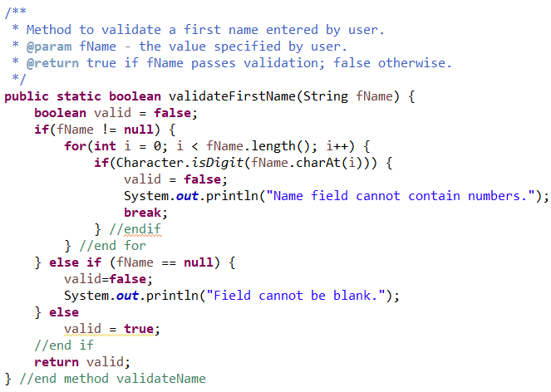

Figure First name validation

And the corresponding testing results:

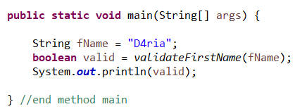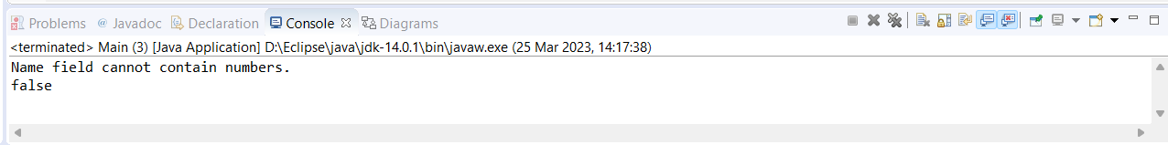

Figure Testing first name validation

An alternative was also created making use of a simple regular expressions:

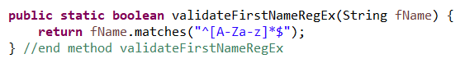

Figure First name regular expression

And the corresponding testing results, which includes testing a name that starts with a number (number 3 is near letter "e" on QWERTY keyboard, so test uses a name beginning with the number 3:

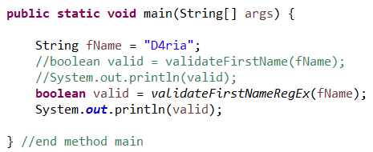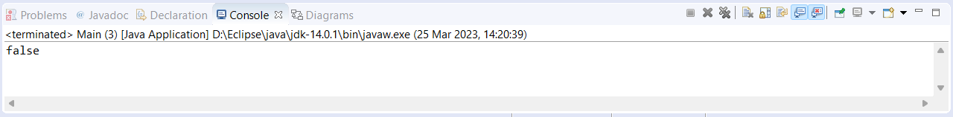

Figure Testing first name regex

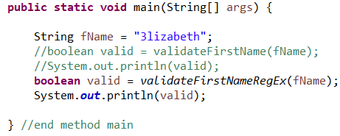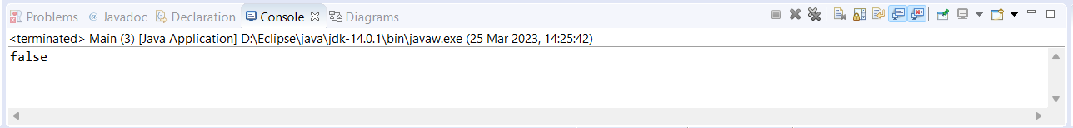

Figure Testing first name regex

However, this doesn't account for any length of a first name. As it stands, the user could leave the first name field blank and the above validation would accept it. It's outlined very clearly in the solution planning report that this field cannot be blank. The maximum length of a first name seems to have been overlooked during solution planning, so I have included validation for a maximum length of 25. **This will be brought to the client's attention at the next meeting**. Furthermore, I have also updated the regex to require the first letter to be upper case:

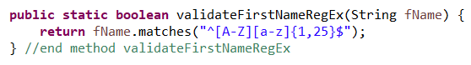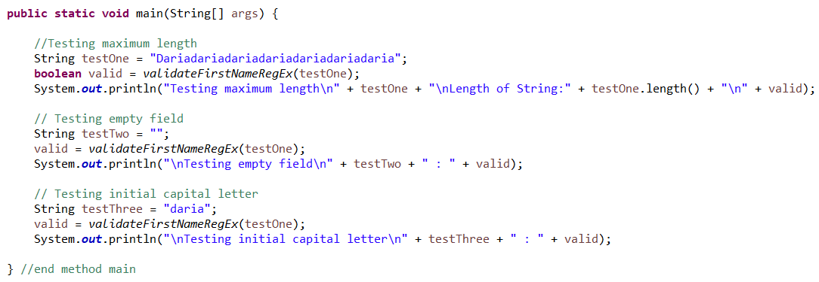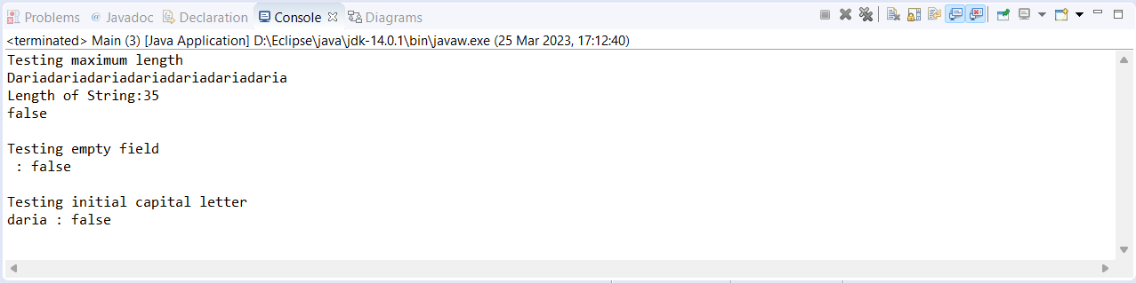

Figure Testing first name regex with min/max length

If we review the data validation rules outlined in solution planning, we can see the same rules apply to a last name. Instead of duplicating our code by creating an additional method named something along the lines of validateLastName(String lName), it would be a better use of time and effort to simply rename the method above to validateName(String name). This makes it more generic and avoids any confusion amongst the development team: it would be misleading to use our method validateFirstNameRegEx(String fName) to validate a last name and a developer might question if this is an error. If we make a very simple amendment to the method name and parameter name, this small block of code can validate at least two fields of data:

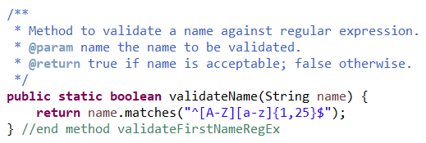

Figure Renaming of validation method

This is one of the benefits that was discussed in the solution planning report – the reuse of code saves time on the overall project. We've already performed some testing on this block of code, so we know it achieves what we want it to achieve. Of course more testing will be performed later in the development phase, but for now it is satisfies the objective of validating a first and last name value.

To briefly summarise the discussion above, the validation has evolved from a long‑winded method that has to first evaluate if the String value is null or not. Then, providing the value is not null, it iterates through each character of the String and evaluates whether each character is a number or not. If the String value makes it through the routine, the boolean flag is then set to true. This was the start of building up a validation routine for name data and didn't take into consideration the maximum length of a name or the initial capital letter. What is achieved in 18 lines of code is then condensed into three lines of code which *includes* testing for maximum length and initial caps:

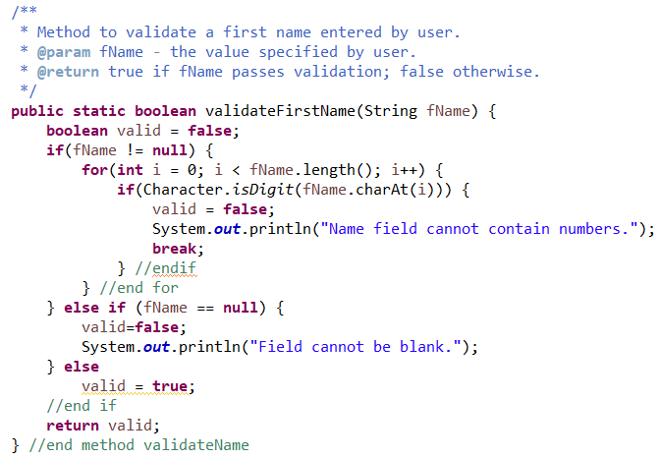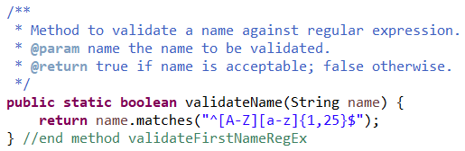

Figure Condensed name validation

### Date of Birth Validation

The SP report refers to using a Pattern class that allows a regular expression to be defined to validate this field. The benefit of this is the compiled regex pattern can speed up the system if the pattern is used frequently, which it is here as all dobs entered must conform to the rules. The Matcher class stores possible matches between the pattern and the String value. If we were to validate a date without regex, the program quickly becomes verbose: to validate the YYYY value a method to verify the value is 4 digits long, starting with 1 or 2:

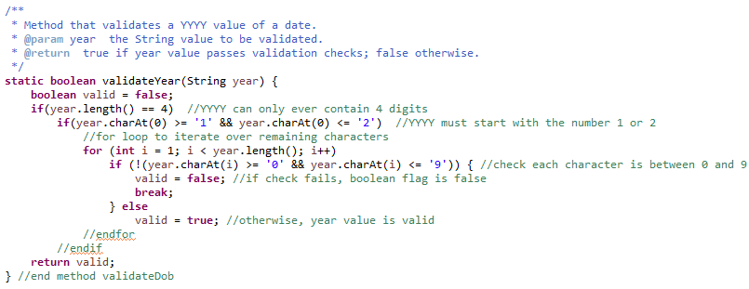

Figure Validating a year value

And corresponding testing results:

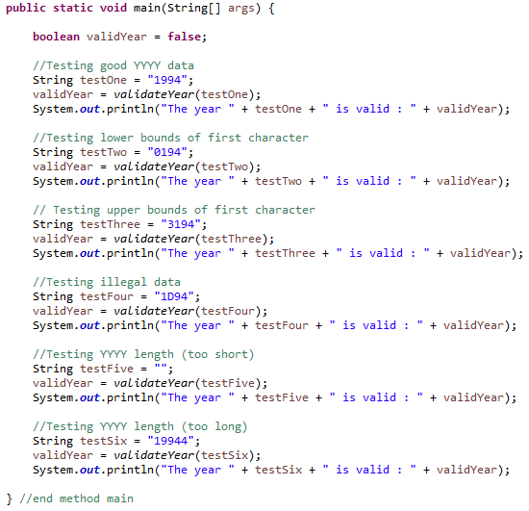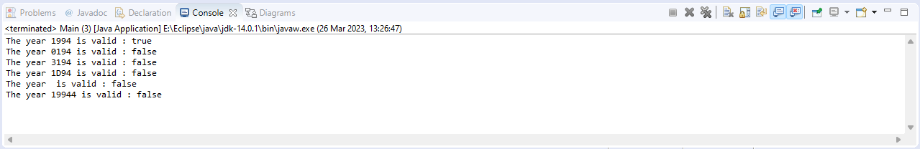

Figure Validating YYYY testing results

To validate a month, the program has to ensure the value contains 2 digits, the first digits being either 0 or 1:

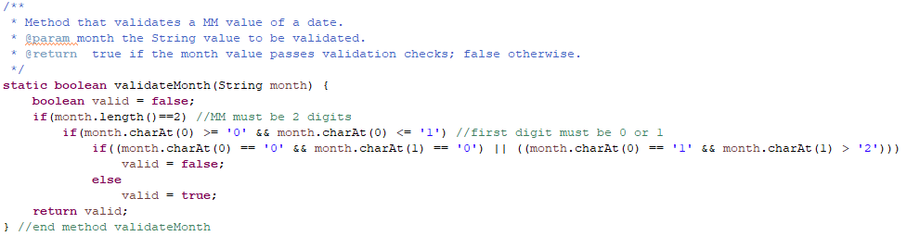

Figure Validating a month value

And the corresponding testing results:

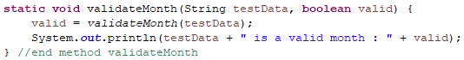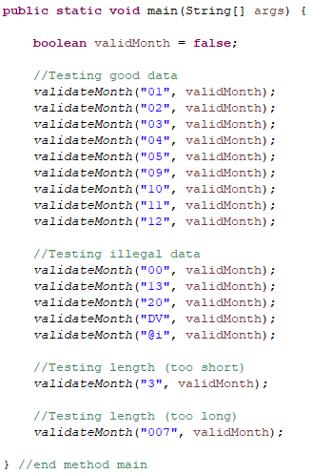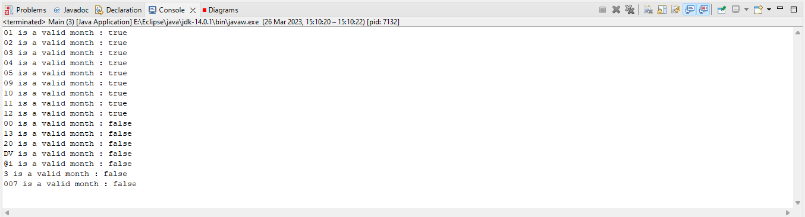

Figure Validating MM testing results

Clearly the program is becoming increasingly verbose as this validation is developed. But I'll finish what I've started. The rules for a day value are:

* Must contain 2 digits
* First digit must be either 0, 1, 2, or 3
* If first digit is 0, second digit must be minimum 1, max 9
* If first digit is 1 or 2, second digit can be 0-9
* If first digit is 3, second digit must be 0 or 1.
* If YYYY modulo 4 is 0 and MM is 02, the upper bounds of DD is 29.

Starting with the first 5 rules:

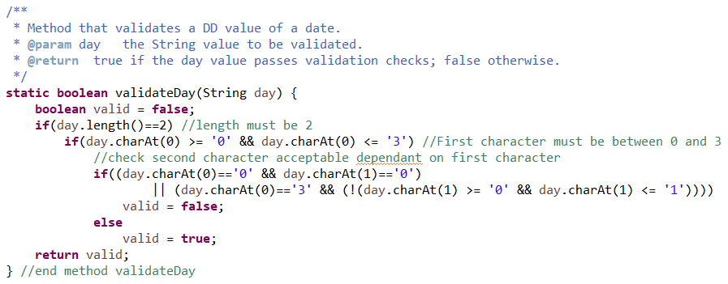

Figure Validating a day value

And the corresponding testing results:

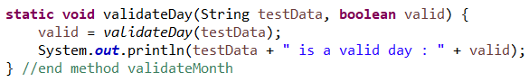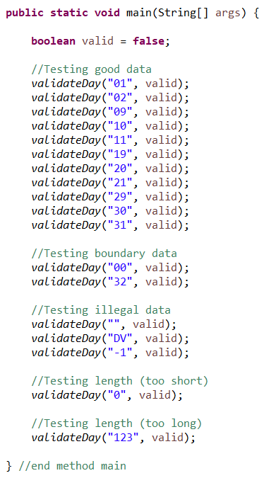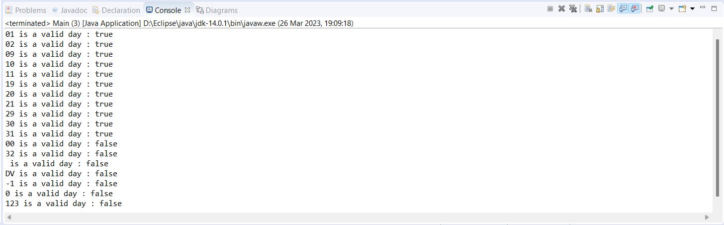

Figure Validating DD testing results

If we glue all of the above together our program would take in user input that conforms to the first five validation rules. But it doesn't take into account that the separator should be in the form of a forward slash and that if it is a leap year, a valid DD value in February can be 29.

As it stands we've already got three methods that work towards receiving an acceptable date format. Before spending more time on adding validation for acceptable values and tying them all together to receive an acceptable date of birth, it's worth researching any regular expressions that are already cooked and ready to use – it's extremely common for a date of birth to be entered in many different forms (like most application forms, account registrations, age-restricted websites (like alcohol websites, just to be clear), to name a few), so it's probable that someone's already done the work for us. As the saying goes, there's no point in reinventing the wheel. The first source I turned to was *Regular Expressions Cookbook* by Jan Goyvaerts and Steven Levithan, who, to my delight, have an entire chapter of regular expressions. In fact, chapter 4.5 is dedicated to dates and offers a potential solution that could be helpful in our project:

^(?<day>[0-3]?[0-9])/(?<month>[0-3]?[0-9])/(?<year>(?:[0-9]{2})?[0-9]{2})$ (Goyvaerts and Levithan, page 260)

Another potential regular expression that may offer a good solution here is taken from javacodeexamples.com. This web page discusses similar validation rules as I've described here and offers a regEx where a day cannot be more than 31, a month must not be more than 12, and a year must contain four numbers:

(0[1-9]|[12][0-9]|[3][01])/(0[1-9]|1[012])/\\d{4} (Java Code Examples, 2021)

I was even more delighted to see that the author of the web page referenced above, Rahim, has already performed a variety of tests on this regular expression. However, just to be safe, I have performed some testing on both regular expressions above to decide which one is more suitable. In testing each regEx, the latter (from Java Code Examples) is far more readable and it does the job of validating the DD/MM/YYYY format:

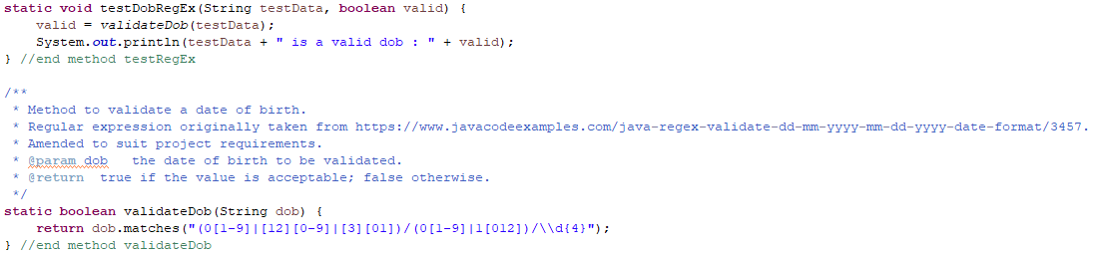

Figure Validating DOB regex, Java Code Examples

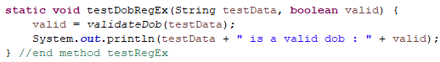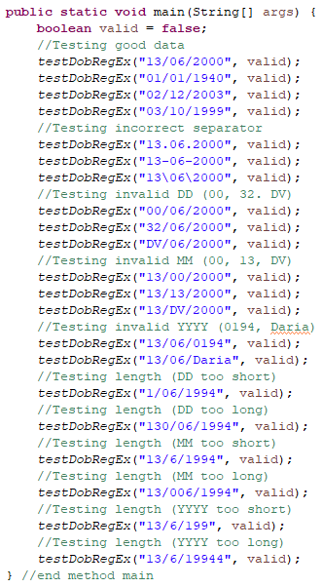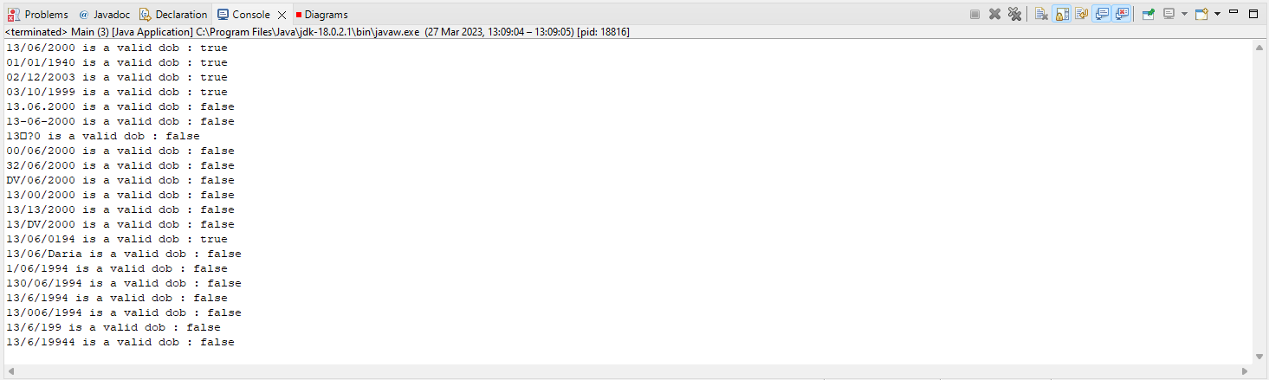

Figure Testing Java Code Examples DOB regex

The same tests were repeated using the regex from *Regular Expressions Cookbook*:

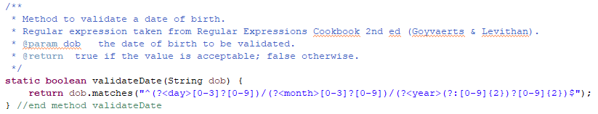

Figure Validating DOB regex, Regular Expressions Cookbook

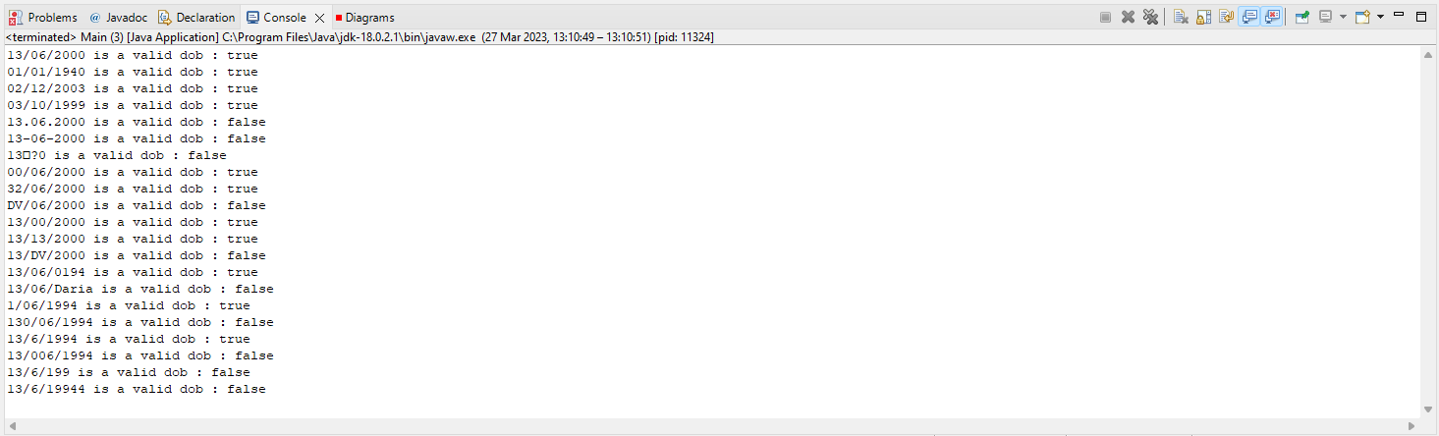

Figure Testing Regular Expressions Cookbook DOB regex

From the output of the initial test results, the regular expression taken from Java Code Examples satisfies our requirements more than the regular expression taken from the Regular Expressions Cookbook. The test results above show that a date with a DD value of “00” or “32” are accepted as valid, a date with a MM value of “00” is accepted as valid, and single figure DD and MM values are accepted as valid. These are not conditions which should be accepted as valid input in our program as we have established in the previous solution planning report that the client has agreed on a date being input in the format DD/MM/YYYY – the graphical user interface design was presented to the client in meeting number 4, the minutes of which detail that the client is happy with the design of the user interface. For ease of reference, when the user wants to add a new case to the system, this is the window they will be presented with:

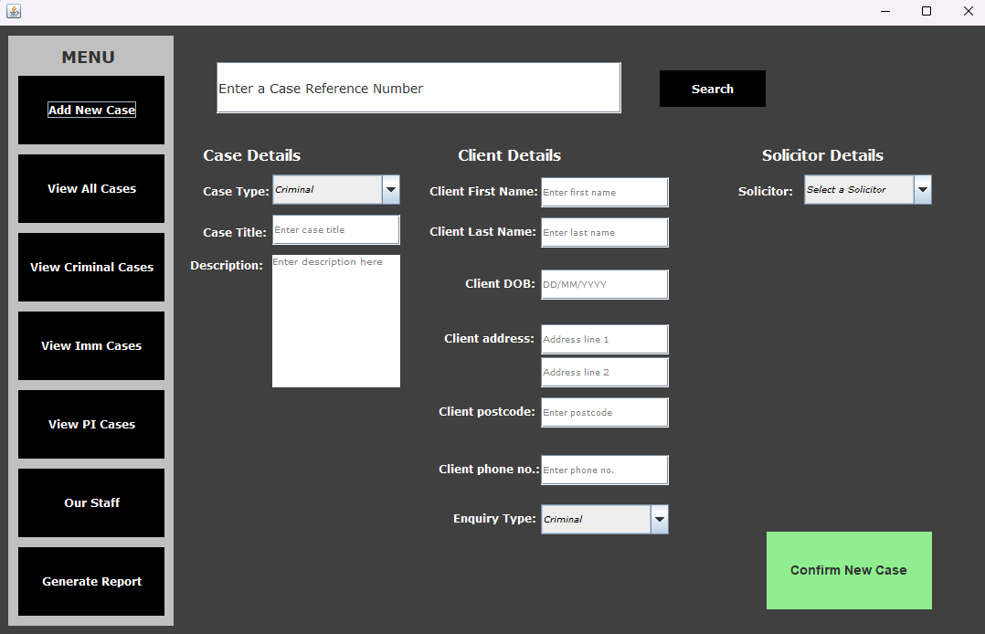

The client has seen this and confirmed they are happy with the design of this interface.

Figure UI design in SP Report

Furthermore, any sensible developer would not write code to accept a “day” value of 32 or a “month” value of 13. It is not really difficult to see why the regular expression taken from javacodeexamples.com is the best option here. Taking this forward to validate the date of birth format, some additional validation code needs to be added to take care of invalid values.

Although it is best to use a regular expression to validate the format, it would quickly become unreadable and excessive if we updated the regEx to validate unacceptable values. Using section 4-2 of Oracle Academy’s Java Programming course as a guide, it would be better in this situation to validate the date of birth values through methods in the DateFormat class. It would make the overall program more flexible and maintainable if we implement the suggestion made in the section Data Validation in the solution planning report, that is to make use of the Pattern class which allows a regular expression to be defined and speeds up the system if the compiled pattern is used frequently, and also the Matcher class which can store possible matches between a Pattern and a String:

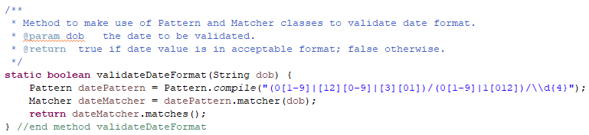

Figure Validating DOB using Pattern and Matcher

And the corresponding testing results:

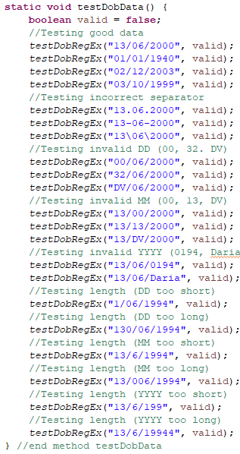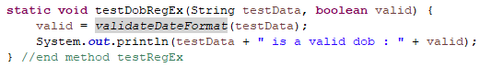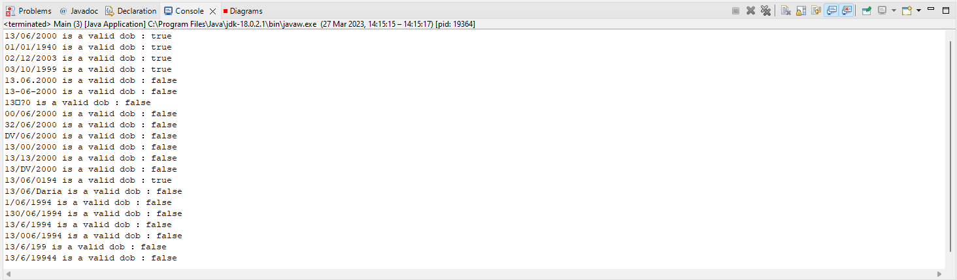

Figure Testing DOB validation with Pattern and Matcher

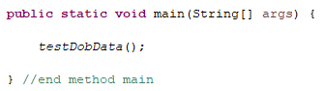

So we have now made the overall system a little more flexible and maintainable by making use of the Pattern and Matcher classes. Now to take into account invalid values, like the upper bounds of February if it’s a leap year:

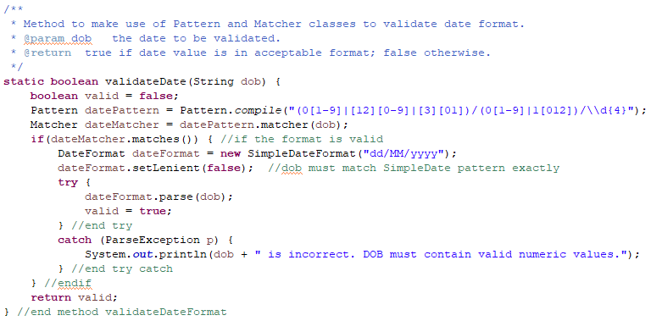

Figure Validating DOB values

In the code snippet above, I have updated the method previously named validateDateFormat to validateDate and have included validation for invalid values. It still makes use of the Pattern and Matcher classes, but now evaluates the validity of the dob value in a simple if statement. If it fails this check, the Boolean flag valid remains false. If it passes this check and is in a valid format, the method proceeds to construct a SimpleDateFormat object using the pattern “dd/MM/yyyy”. The SimpleDateFormat class is a concrete class which extends DateFormat, allowing for the formatting, parsing, and normalization of dates (docs.oracle.com, n.d.). The abstract class DateFormat allows us to use the setLenient method to specify whether it is acceptable for the date value to differ from the pattern specified. This is set to false because we would like the dob value to be an exact match to the pattern specified, which will ensure the client’s system stores this data in a consistent manner (i.e. the system can’t allow a user to enter a date of birth in format MM/DD/YYYY as this will just cause confusion). The method then enters the try/catch statement – when it executes the instruction to parse the dob value, there is a possibility that a ParseException will be thrown if the dob value is not valid. Therefore the appropriate error handling is vital here. If the parsing is successful, the dob value is valid and our Boolean flag is set to true; otherwise, the Boolean flag remains false.

The below code snippet demonstrates the testing of the updated validation method. It tests for invalid values such as 29/02/2000 which should output true to represent a valid date (2000 is a leap year), and 30/02/2001 which should output false to represent an invalid value (that date does not exist).

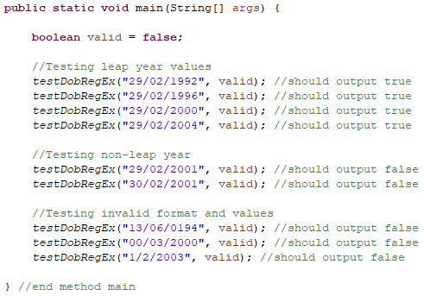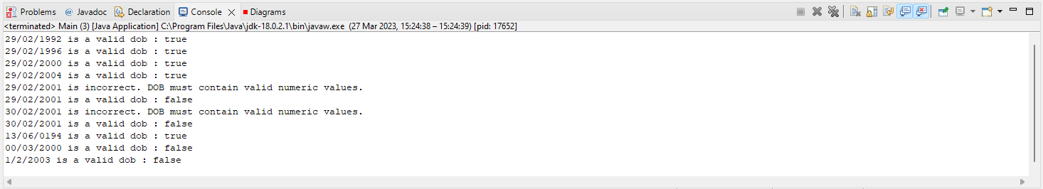

Figure Testing DOB validation

The output above is satisfactory apart from one test case. The validation still accepts a YYYY value beginning with 0 as valid. It is incredibly unlikely that a date of birth will be entered with a YYYY beginning with 0, so in a bid to try and make the user experience a little smoother I will add in another check to the method – as it stands, the user may enter 0 in error and not realise their mistake until after confirmation, so it is good form to try and account for this now. Realistically, the YYYY field is probably only ever going to start with a 1 or a 2, so we can evaluate this with an additional if statement that evaluates the YYYY value by making use of the group() method from the Matcher class:

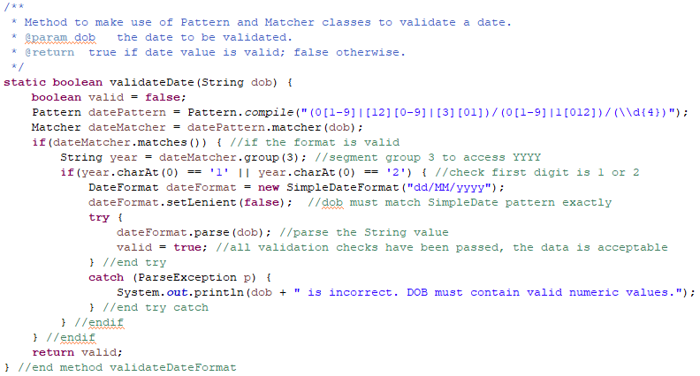

Figure Updated DOB validation

Now, when the tests are rerun, a YYYY value beginning with 0 now results in the Boolean flag remaining false:

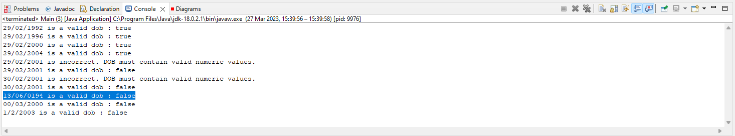

Figure DOB tests rerun

### Address Validation

This field can't be too strict in terms of validation rules as address data is far too varied to make use of a common regular expression. If too many validation rules were implemented on an address field, it can result in a system that becomes unusable for the user. The SP report talks about HCI and the user experience, so to make this as user friendly as possible we can add simple validation to check the field is not null and contains alphanumeric data. Chapter 4.8 of *Regular Expressions Cookbook* offers a few solutions for limiting input to alphanumeric characters; three of them could be used in this context:

* “^[A-Z0-9]+$” which can be used to limit user input to one or more alphanumeric English characters;
* “^[\x00-\x7F]+$” which can be used limit user input to 128 characters in seven bit ASCII character table; or
* “^[\n\r\x20-\x7E]+$” which can be used to limit user input to ASCII characters excluding non control characters and line breaks.

(Goyvaerts and Levithan, pp.275-276)

Given that the SP report has shown the address will be taken in over two lines, the validation for these fields should allow for characters other than letters and numbers. For example, receiving the address over two lines means the user can type in an address as:

**Line 1**: House number, Street name, Town

**Line 2**: County, Country

This means that the system should accept characters like commas, dashes and ampersands, to name a few. There is only so much a digital application can do as far as addresses are concerned – we can’t take *all* responsibility off of the user in this context as postal addresses are so varied. So, I believe it is a sensible option to opt for implementing the third regular expression listed above to accept ASCII characters excluding non-control characters and line breaks. There will simply have to be some care taken on the user’s part to enter an address accurately. To perform some testing on this, the encoding preferences in the IDE were changed:

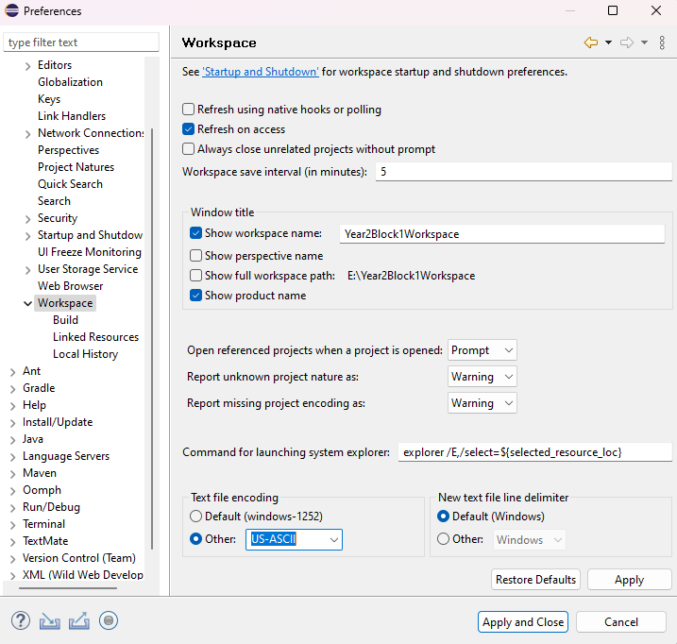

Figure Encoding preferences

The code snippets below show the implementation and testing of the chosen regular expression to validate the address input:

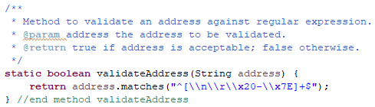

Figure Address validation using regular expression

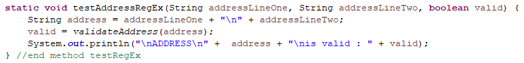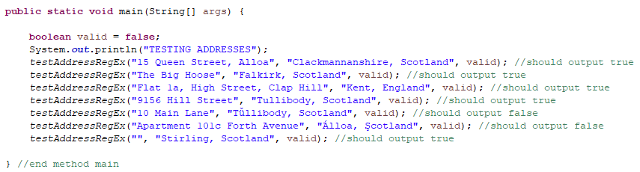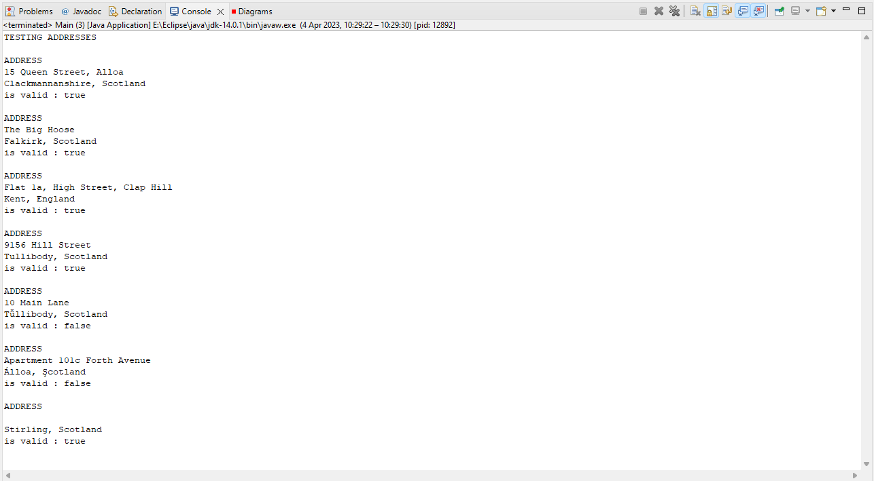

Empty field is currently evaluated as valid data.

Figure Address validation testing

The Data Validation rules in solution planning are very clear in that the address field cannot be left blank. From the above output, the current validation does not go far enough to check for an empty field. A few tweaks to the current validation routine:

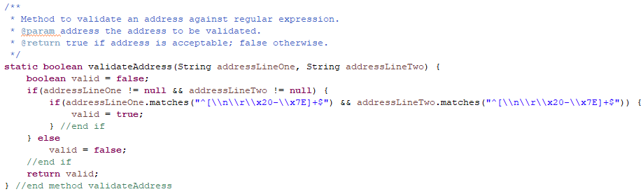

Figure Updated validation

And the rerun of tests using the same test data:

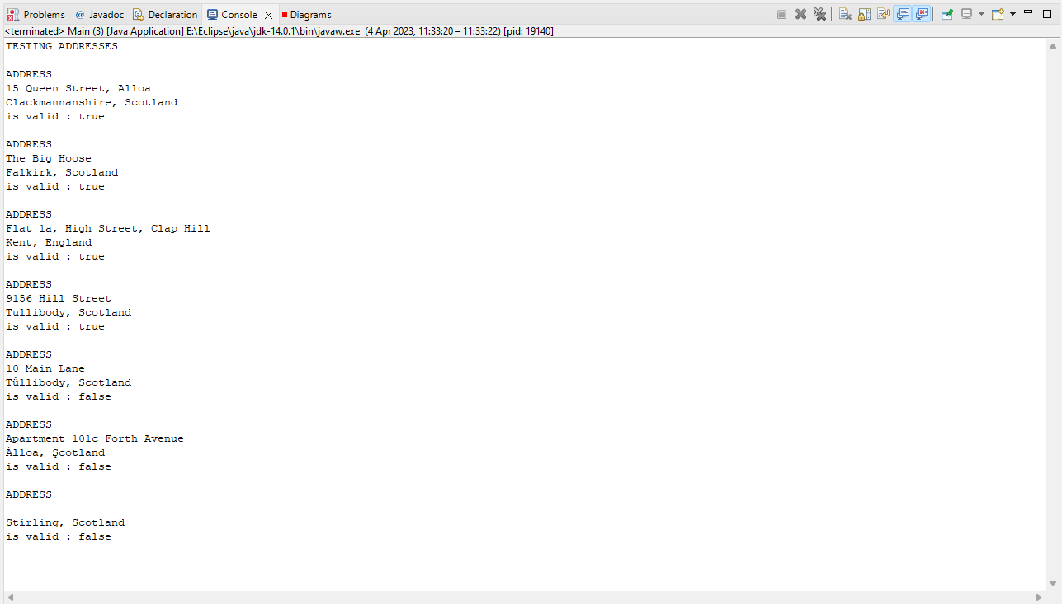

Figure Address testing rerun with updated validation

### Postcode Validation

The postcode is a crucial piece of information when correspondence is being sent to one of the firm’s clients. If the address has an error in it, an accurate postcode can indicate the intended recipient address. The SP report specifies a few basic rules:

* Minimum 5, maximum 7 alphanumeric characters
* Only separator allowed is a single space

It also suggests testing the regex included in *Regular Expressions Cookbook*:

"^(?:(?:[A-PR-UWYZ][0-9]{1,2}|[A-PR-UWYZ][A-HK-Y][0-9]{1,2}|[A-PR-UWYZ][0-9][A-HJKSTUW]|[A-PR-UWYZ][A-HK-Y][0-9][ABEHMNPRV-Y])●[0-9][ABD-HJLNP-UW-Z]{2}|GIR 0AA)$"

(Goyvaerts and Levithan, p.303)

However, when I test this regular expression against my personal postcode (which I know is accurate and valid), the Boolean marker is false:

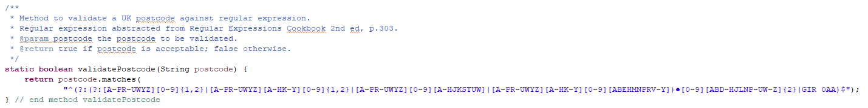

Figure Postcode validation regex

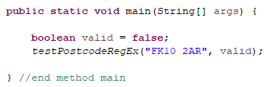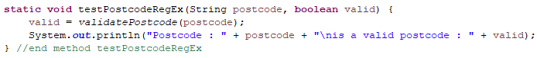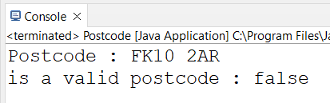

Figure Testing postcode validation regex

Other regular expressions for UK postcodes can be found with a little research, so before I decide to amend the above regex I decided to quickly test some other regular expressions.

The regular expression taken from GOV.UK (BULK DATA TRANSFER: ADDITIONAL VALIDATION FOR CAS UPLOAD, n.d.) seems reliable after some initial testing. This doesn’t allow for postcodes that are entered without a space. The SP report states the only separator which should be accepted is a space, but doesn’t explicitly state that the system should enforce this on to the user. **Since this regular expression appears to be reliable, it should be confirmed in the next client meeting if they are happy for the system to require the user to enter a postcode with a space as a separator. The initial tests can be showed to the client to demonstrate what is meant here. Also good to confirm if client would like the system to accept PO Box addresses**.

The implementation of this regex is shown in the code snippet below:

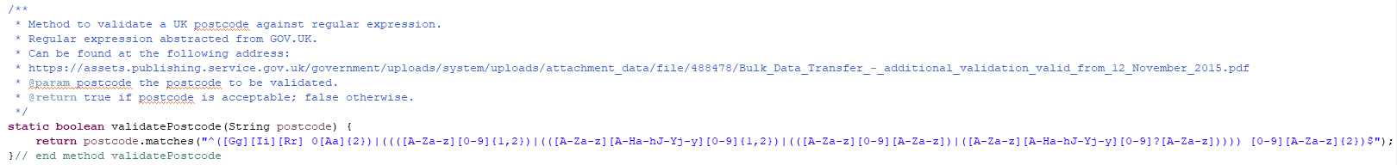

Figure Postcode validation using regular expression

The following code snippets show the testing of this regex along with the output:

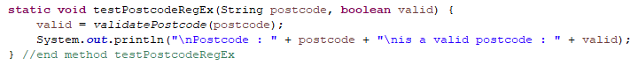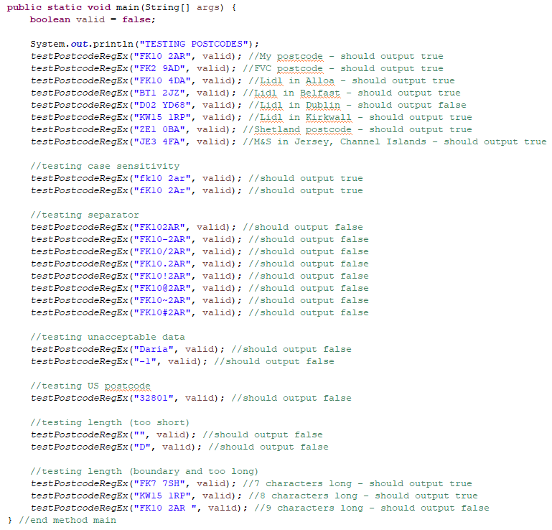

Figure Testing of postcode validation

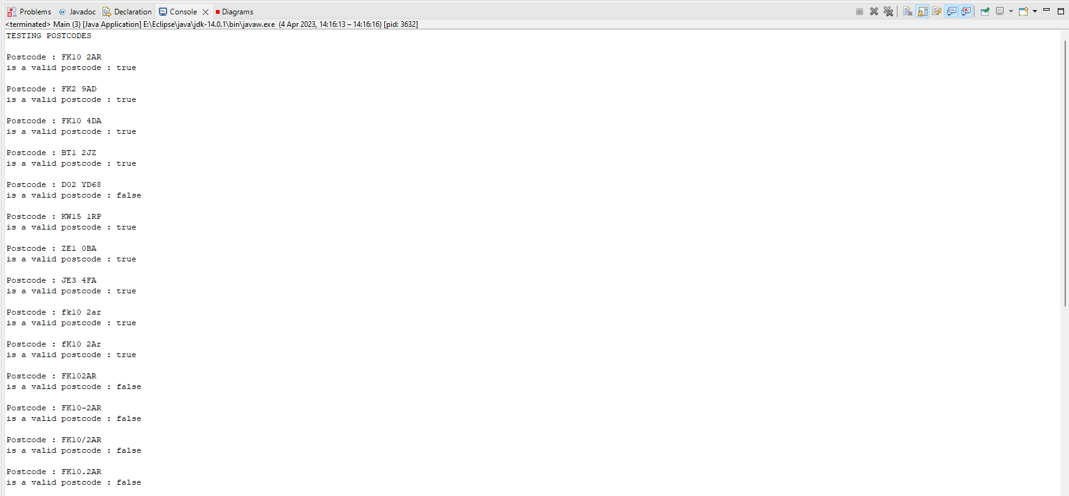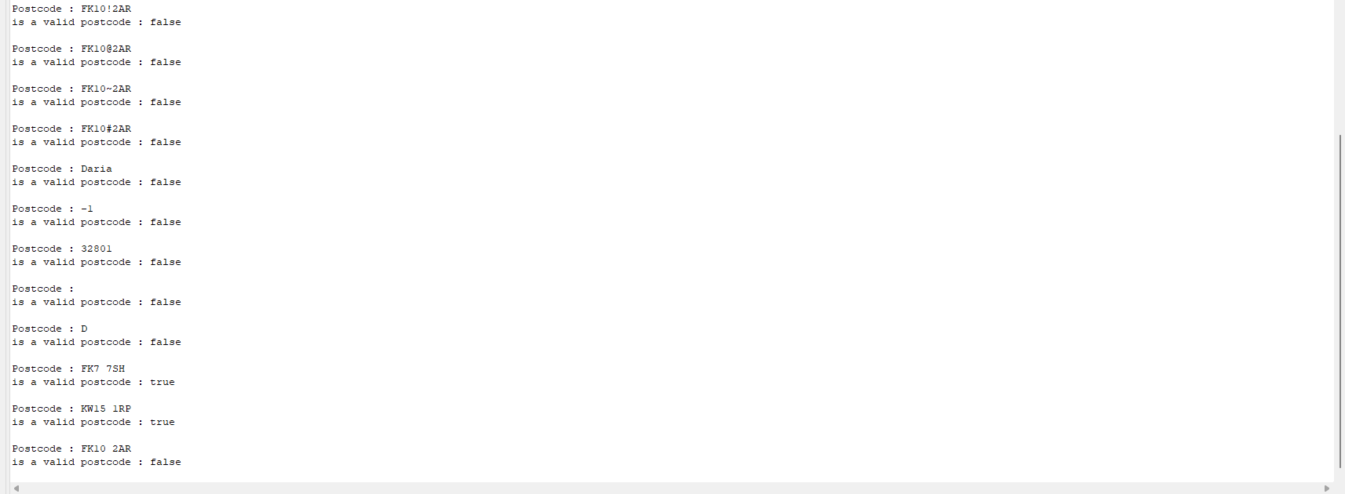

Figure Postcode validation testing output

### Phone Number Validation

The SP report states this field must contain digits only, start with the number 0, and be 10 digits long. The length of 10 digits does not include the 0. This means that the true length is 11 digits long (including the leading 0).

**It seems the business rule is to allow mobile and landline phone numbers. Therefore validation will not take into account international dialling codes. Clarify this with client and demonstrate what will be considered valid data with current validation.**

The code snippet below shows a regex to stipulate the data must start with 0 and contain another 10 digits:

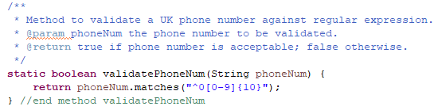

Figure Phone number validation with regex

The code snippets below show the results of initial testing of this regular expression:

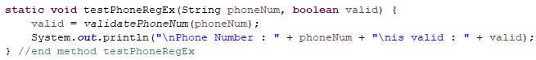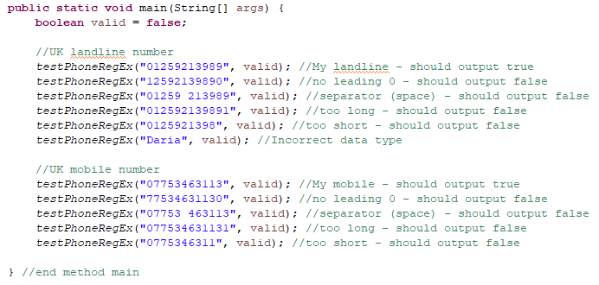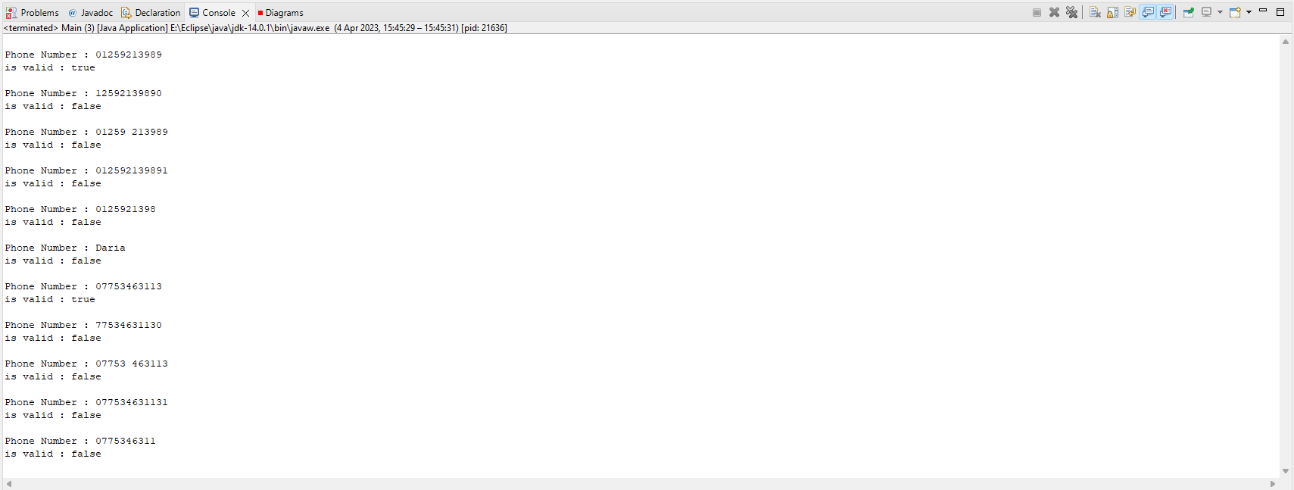

Figure Testing phone number validation

To make the user experience slightly smoother, the validation can be amended to allow the user to enter spaces:

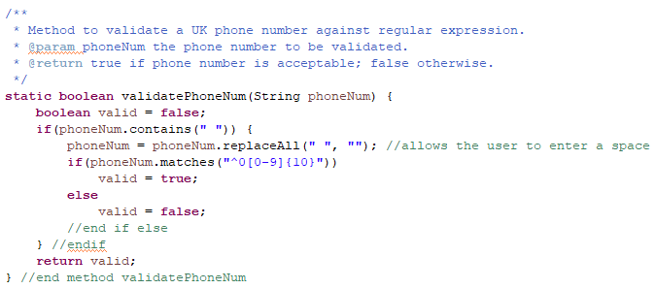

Figure Updated validation allows user to enter spaces

The output below shows a user will be able to enter a space in a phone number:

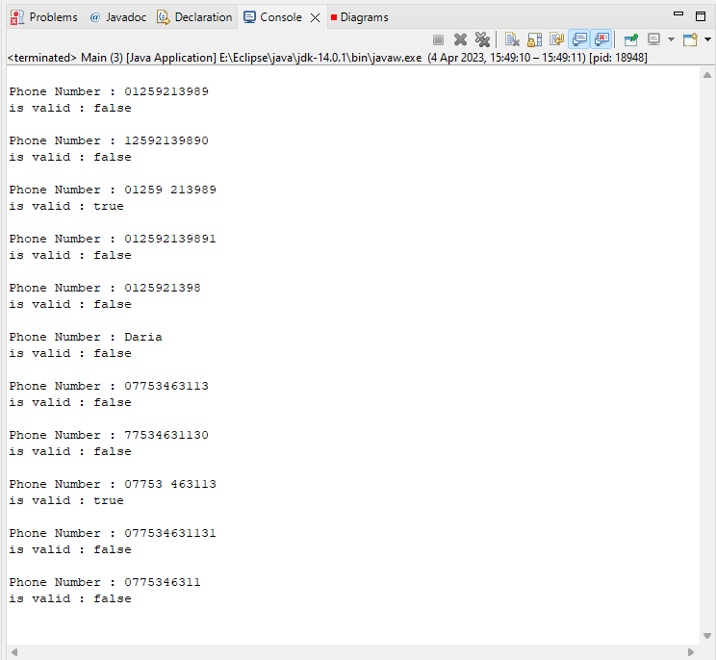

The user can now enter a space without swearing at the system.

Figure Updated phone number validation test runs

### Case Title Validation

The SP report tells us a case title should be in the format [client surname] v [opponent]. Only the employee will know if the surname and opponent are correct, so we can only take our validation so far. What we can do is establish if the user has entered the “ v “ in the case title. It's a possibility to explore using the split() method to validate this – the Oracle Academy Java Programming course didn’t go into great depth into how to use this method practically. It explains that we can split a string around matches of a given regular expression and it returns the split Strings in an array of Strings. The optional parameter of the split() method is the regular expression which describes where the String should be split. The OA slide (JP Section 4-2, slide 41) offers a brief example of splitting a String at any sequence of one or more digits. This seems like a good method to make use of in validating a case title as we can first check if the user has included “ v “ in the title – if they’ve not, the first check is failed – and then proceed to split the String so we can make use of our earlier name validation method.

To investigate this a bit further, I have tested using split() using a hard coded String:

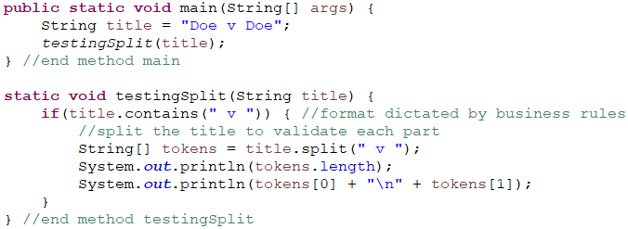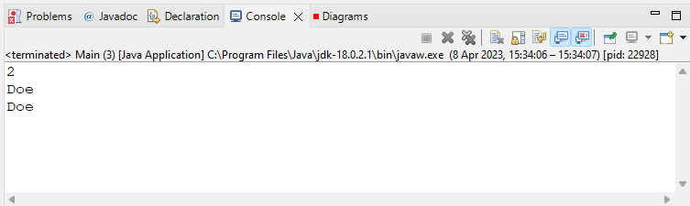

Figure split() method splits String around matches of regex and returns an array of Strings

The code snippet below shows some testing of bad data with an updated error message:

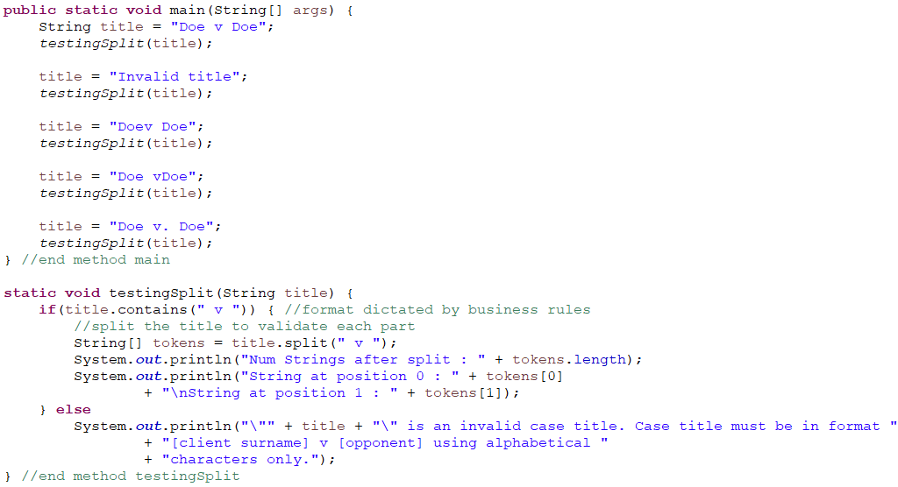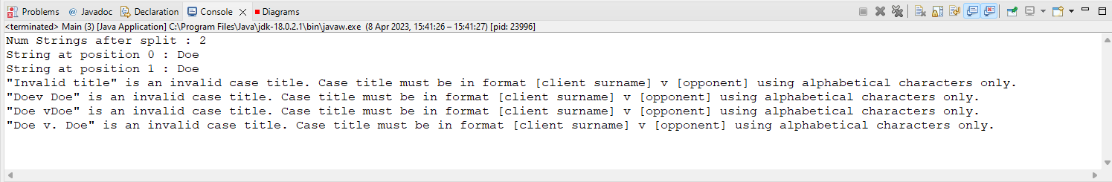

Figure Case Title validation testing bad data

After this check, we can then make use of the method defined earlier that uses a regular expression to validate a name. As a Case Title is essentially two names (client surname and opponent name) separated with “ v “ in the middle, we can proceed to use this method to validate each String after the split, as the code snippet below tests:

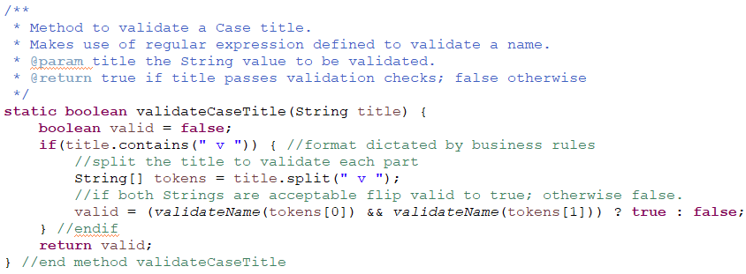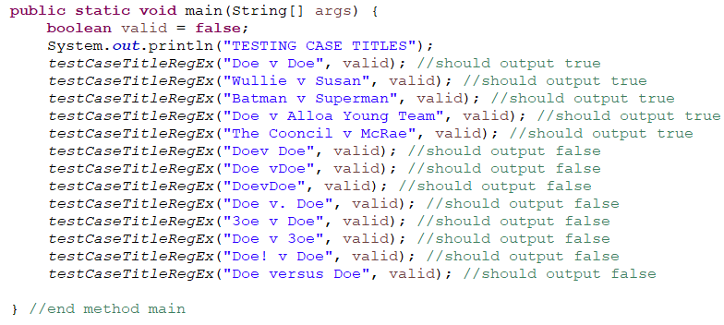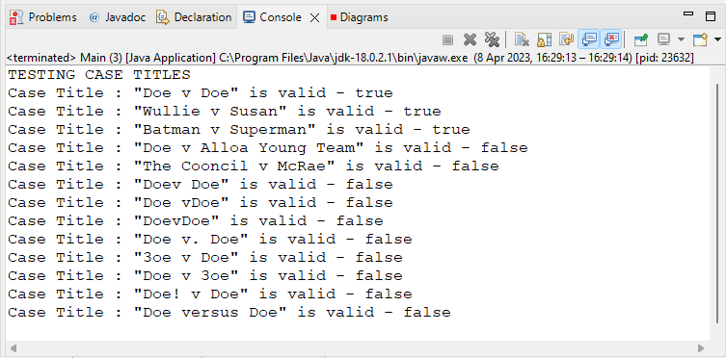

Should allow for multiple words before or after the “v”.

Figure Testing Case Title validation

The output is as expected apart from where a String contains more than one word. This is probably because the regex for a name doesn’t allow spaces to be accepted. It is worth testing a modification to this regex so that it allows for spaces. A regex that only allows for a String to: contain alphabetical characters and allow for spaces; and is, followed by a “v” which is then followed by one or more alphabetical characters, allowing spaces:

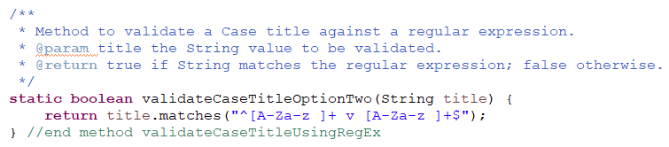

Figure Case Title validation regex

The code snippet below shows the testing of this regular expression:

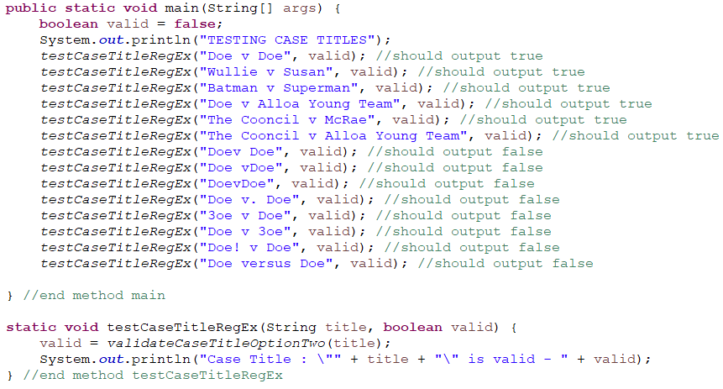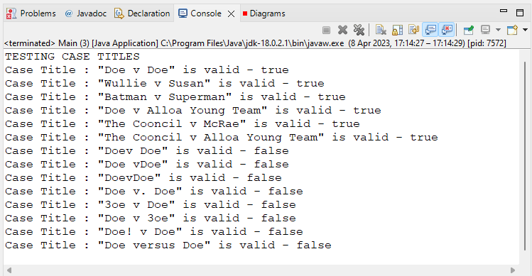

Figure Testing Case Title regex

From the output above the regular expression clearly allows for Case titles that contain one or more words before and/or after the “ v “. Given this suits the needs of the business more than the first validation routine for a Case title, I will opt to make use of the regex above as it is far more readable and concise than splitting the String input and then validating each item in the String array.

Only field left to validate in terms of adding a new Case is the Case Description box. This should allow the user to enter a variety of data. The Sol Plan report doesn’t report any specific validation rules and as there could be a wide variety of data entered here I do not want to impose any strict rules on the user. In other words, there is not really any sensible validation that the programmer can include here. **It might be worth asking the client if they want a maximum limit of characters placed on this input**. The most important point to note is that it cannot be empty. A simple method to check if a String is empty:

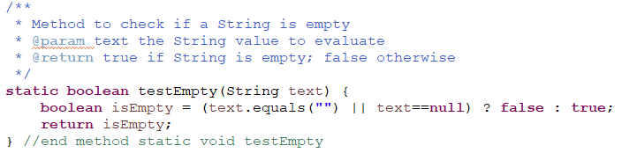

Figure Validating empty input

## What Now?

All of the validation methods have been programmed in their own Java project. I did this to allow me to focus just on getting the validation of data done. If I tried to organise my overall system correctly from the outset, I tend to get too bogged down in how everything is going to interact. Creating a separate project consisting of just a Driver class allowed me to concentrate solely on what the data validation rules are and allowed me to quickly and easily test a variety of data in the main method to see if my validation methods satisfied the business requirements of the project.

Most of the user input will be received when the user wants to add a new Case to the system. This is quite a big use case and requires the most validation compared to any other use case, so I wanted to try and spend a decent level of effort on getting this use case implemented well. It's the use case that forms the backbone of the evolving system (it's a case management system, after all, and there would be no business value in a case management system if the client can't even add a new Case to the system).

Having defined a variety of methods to validate user input leads me to question how best to organise the overall program, considering it's been established from the onset of the project that a graphical user interface is needed. The units studied in this course so far have placed emphasis on Object Oriented Programming, along with Object Oriented Analysis and Design. However, some design patterns are not included in the course curriculum, so this seems like a worthwhile opportunity to explore some suitable software architectural patterns that could improve the flexibility of this program, even if it means straying away from the solution proposed in the Solution Planning report.

### General Responsibility Assignment Software Patterns

In *Applying UML and Patterns*, Larman refers to General Responsibility Assignment Software Patterns (GRASP) as a set of design principles that are proven to solve common and recurring object‑oriented software design problems. The five patterns that appear to be particularly noteworthy are:

* Information Expert
* Creator
* High Cohesion
* Low Coupling
* Controller

(Larman, p.220)

Also included under GRASP is Polymorphism, Pure Fabrication, Indirection, and Protected Variations, but Larman advises the five listed above should be mastered first before exploring the latter. In other words, an inexperienced object‑oriented designer/developer is better placed to start with the simpler and most common principles as they are very likely to be used by a high number of object‑oriented systems and probably in larger systems too.

The design principles known as GRASP patterns didn’t spring out of nowhere – they have evolved over time as software developers have faced issues and then documented their tried‑and‑tested way of solving problems that are common to software development projects. Grady Booch states in his Foreword to *Design patterns : elements of reusable object-orientated software* (1995) that the authors, the “Gang of Four have made a seminal contribution to software engineering. There is much to be learned from them, and much to be actively applied.” (Brooch, p.12). This Gang of Four write:

Experienced object‑oriented designers will tell you that a reusable and flexible design is difficult if not impossible to get “right” the first time. … Yet experienced object‑oriented designers do make good designs. Meanwhile new designers are overwhelmed by the options available and tend to fall back on non‑object‑oriented techniques they’ve used before. (Gamma et al., 1994)

This is comforting to hear given the static and dynamic model offered in the Solution Planning report submitted previously felt slightly disjointed to me and given that I have defined validation methods somewhat procedurally in a simple Driver class. It seems there is a transition to be made from learning to program in a procedural fashion to developing an application in an object‑oriented way – one that I am clearly still making! It seems like a big part of making that transition is in how a program is organised.

### Model, View, Controller

The Model, View, Controller (MVC) design pattern is one way of organising code, where each section (the model section, the view section, and the controller section) has a clearly defined purpose. Although the Solution Planning report submitted previously did not explicitly mention GRASP patterns, it did include some discussion on software that is designed with high cohesion and low coupling (especially pages 95-96). In summary the Solution Planning report suggests that software that is loosely coupled is more easily extendable and reusable. The MVC framework is one organisational technique of achieving this. It is common for website applications to be organised using the MVC framework: see, for example, Blake Schlin’s very brief blog entry *What the f**k is MVC? Explained with easy analogy*[1]; and also MDN Web Docs glossary entry *MVC on the web*[2]; and also w3schools’ page *What is MVC Architecture?[3]*; and also tutorialspoint’s page *MVC Framework - Introduction*[4]. MVC is discussed in a website development context in all of these sources.

However, its use is not limited to web applications. It’s fundamentally just a technique of code organisation, so it is just as effective and applicable for a Java program as it is for a web app. Its effectiveness and suitability for a wide range of development approaches (web, OOP) is a signifier of its **adaptability** – it’s tried‑and‑tested, so it’s popular amongst many experienced software designers/developers/engineers. A good description of MVC is offered by codeacademy: “*MVC is a way to organize your code’s core functions into their own, neatly organized boxes*” (Codecademy, n.d.).

#### Model

The **Model** code refers to the business logic. This is where the blueprint of what’s important to the business domain is laid out. The Model’s responsibility is essentially to store and update data, so it is common for the Model layer to contain Plain Old Java Objects (POJOs). So, to think back to Solution Planning, the software classes that were arrived at through CRC cards are likely to be defined as Java classes in the Model box. This means the Model will contain, for example, a Person, Employee, Client, and Case class.

#### View

The **View** is simply what the user will see on their screen. It contains the code that constructs the user interface and defines how the system will look. It is solely responsible for presentation, so it should be able to access the data in the Model but it should not know what this data represents or how the user is able to (if at all) manipulate the data.

#### Controller

The **Controller** is sometimes referred to as the brain of the system – it is responsible for deciding what to do when an event occurs. It is the Controller that connects the Model and the View and acts as the messenger man. A good analogy of the overall picture is offered by codeacademy:

It’s kind of like how you make Thanksgiving dinner. You have a fridge full of food, which is like the Model. The fridge (Model) contains the raw materials we will use to make dinner.

You also probably have a recipe or two. A recipe (assuming you follow it exactly) is like the Controller of Thanksgiving dinner. Recipes dictate which stuff in the fridge you’ll take out, how you’ll put it together, and how long you need to cook it.

Then, you have table-settings, silverware, etc., which are what your hungry friends and family use to eat dinner. Table-top items are like the View. They let your guests interact with your Model and Controller’s creation.(Codecademy, n.d.)

There are many graphical representations of the MVC organisational technique available. A simple and accurate visualisation of MVC is offered by fireup.pro:

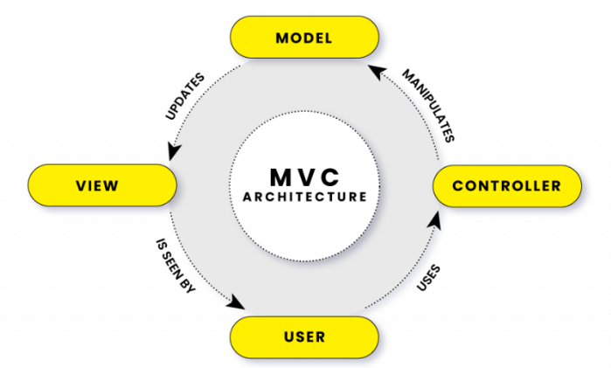

Figure MVC Organisation (fireup.pro, n.d.)

As the Controller is really the only section the user interacts directly with, this is potentially where the data validation methods that led me to MVC could be included. I am inclined to include data validation in the Controller section because, from my understanding, the data input should not reach the Model in a state that we don’t want to store it in. For example, the user is viewing the AddNewCase interface, they have entered a postcode that doesn’t exist, the user presses “Confirm”, this action is received by the Controller – the Controller now has to decide what to do: the data isn’t in an acceptable state for the Model to create a new Case, so rather than sending this data to the Model for validation and waiting for the Model to respond with yay or nay, it would be more efficient for the Controller to assess whether the user’s input is acceptable or not. Only once the Controller has received good data can it be sent to the Model for the construction of a new Case object to be stored in the system.

The Controller is defined as a pattern in itself as outlined in the GRASP principles above. Larman explains that the Controller pattern presents a decision to be made by the designer, in that it either “represents the overall “system,” device, or subsystem”; or “represents a receiver or handler of all system events of a use case scenario” (Larman, p.238). A good visual representation that helps to demonstrate the choices available is also provided, and I have reproduced a similar figure to visualise these choices in the context of this project:

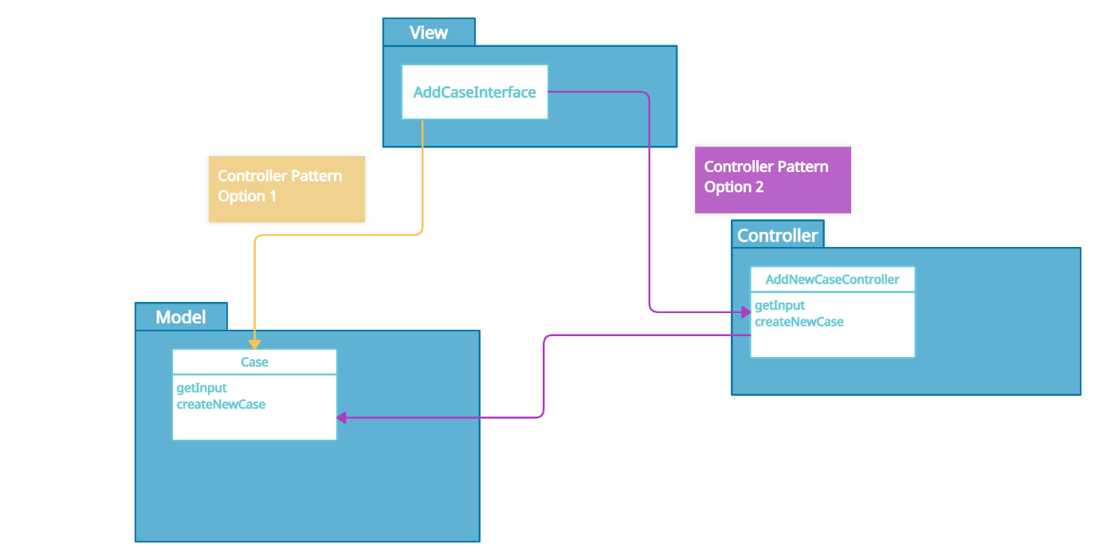

Figure Controller Pattern Choices

From the above figure the Controller could be contained within the Model section – the section responsible for the business domain. Likewise, it could be contained in its own layer, referred to by Larman as “Session Facades” that is recommended in option 2, the “use-case session facade controller” (Larman, p.459).

Keeping in mind my intention is for the MVC framework to help in avoiding low cohesion, the latter is likely to be the better route. If a controller class represents the overall system, then there is the risk of assigning too much responsibility to that class. The purpose of Controllers is not to carry out absolutely all of the work of the entire system (a “bloated” controller (Larman, 2005)), but to delegate the right jobs to the right objects. It wouldn’t be wrong to opt for a facade controller in this project because it is not exactly a large or sophisticated software that is being developed. However, in reality I imagine software systems require the capacity to grow without causing too much unnecessary work, so in an attempt to avoid a Controller class becoming too bloated, I intend to organise the system with dedicated use case controllers.

To zone in on the “Add New Case” use case, the organisation of the evolving system includes three packages. Using the class diagram provided Solution Planning as a guide, I have implemented a Java project with components required for this use case adhering to the MVC framework:

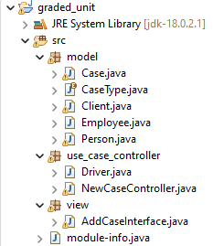

Figure Program organisation adhering to MVC technique

#### Code Migration

The data validation methods can now be migrated to the Controller class NewCaseController. In implementing this migration,. I took the opportunity to practise using the ternary operator for two reasons: (a) I tend to shy away from this and wanted to understand how to implement it better; and (b) it’s a good way to condense some blocks of code therefore enhancing readability and optimisation. For example, the method to validation a phone number before and after using a ternary operator is shown below:

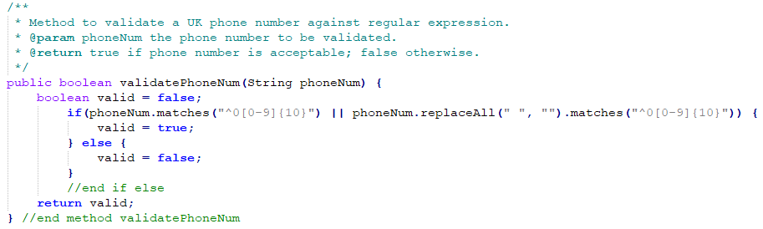

Figure Phone number validation before using ternary operator

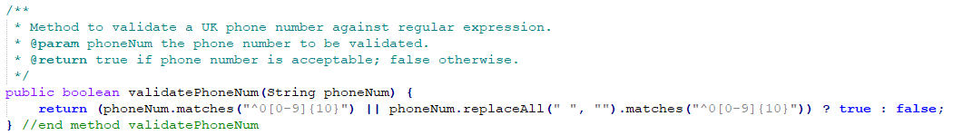

Figure Phone number validation after using ternary operator

As established in the research of MVC so far, the bones of the validation work should be contained to the Controller box. As the Controller is essentially acting as a data manager, we also have to include methods that are required to construct various objects. For example, in order to tie a Case object to a Solicitor object, there has to be a block of code that will retrieve where that Solicitor is in the List of Solicitor objects. So in the class NewCaseController I have included:

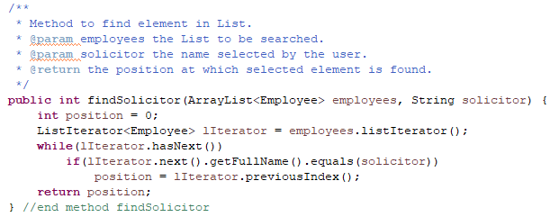

Figure Method to search Employees List contained in Controller class

The example above shows that neither the View or the Model containers are responsible for retrieving the correct Employee object. Here, the user will select the Solicitor name through the GUI (the View):

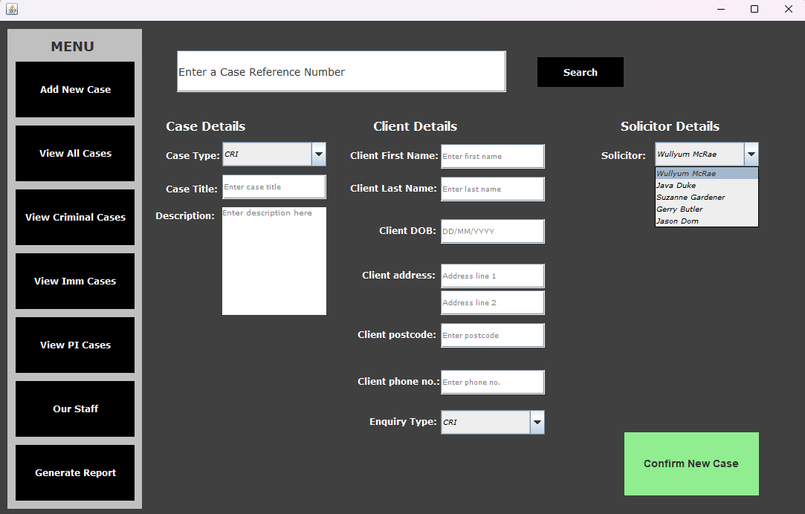

User chooses the Solicitor



Figure User chooses the Solicitor through View

Then, their selection is cast to type String in preparation to be sent to the Controller:

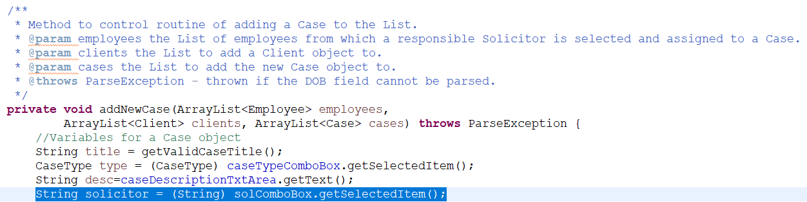

Figure Receiving user's selection through the View

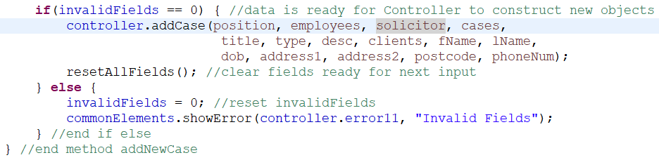

Figure Data sent to Controller

The Controller then manipulates the Model by constructing the new Case and Client objects using the data received:

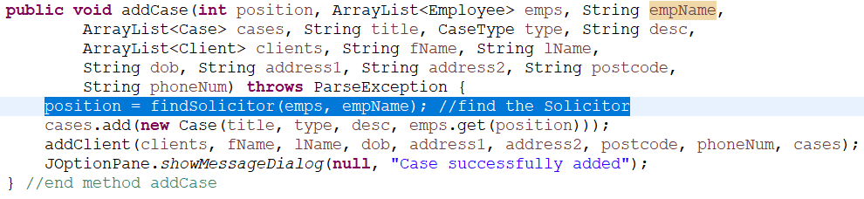

Figure Controller manipulates Model and constructs new objects

To represent the above process graphically:

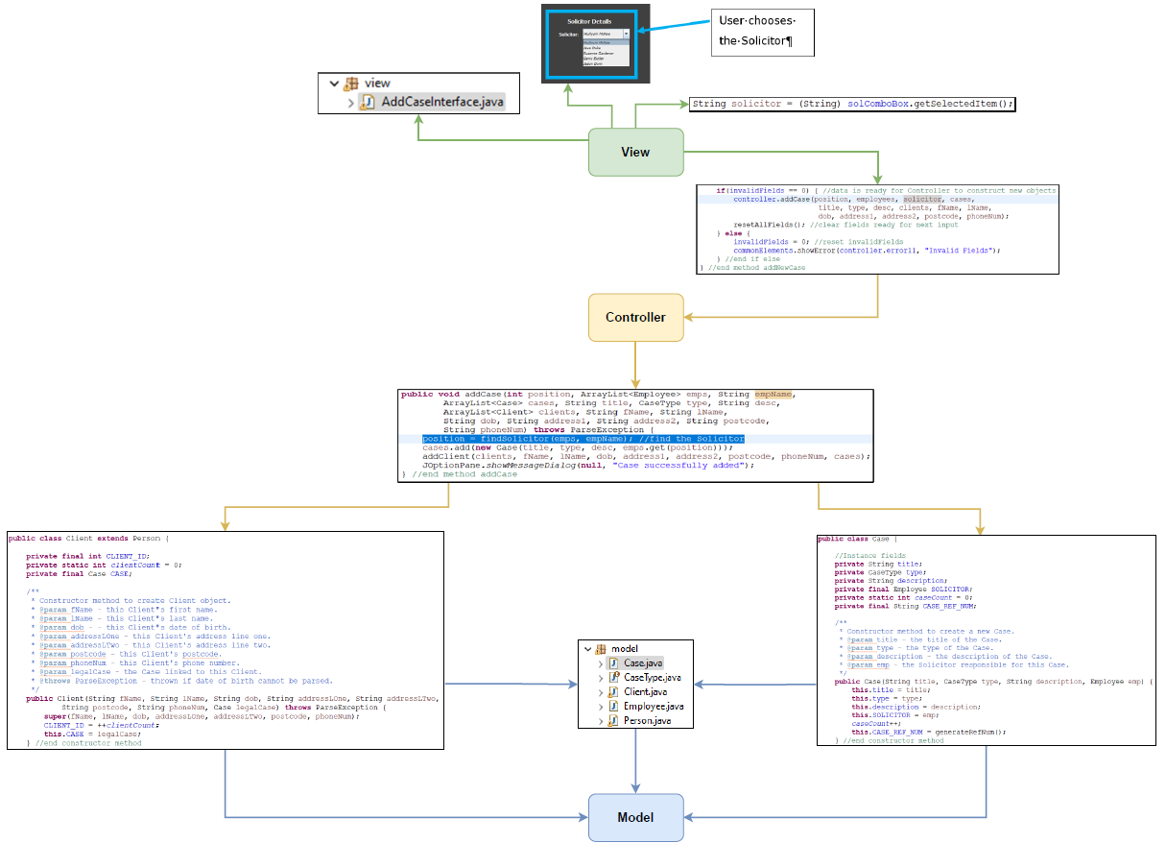

Figure Graphical representation of MVC with code snippets

To adhere to this organisational technique throughout the overall program, the package structure is split into three “containers”:

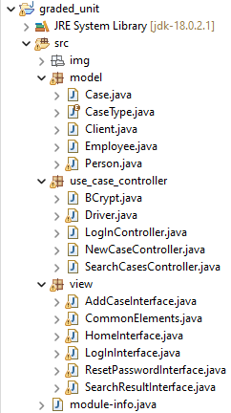

Figure MVC package structure of Java program

### Log In Use Case Controller

With the MVC organisation standard guiding the package and class structure of the program, it is clear from Figure 57 that there is an additional 2 Controller classes. As I have implemented Controller classes according to use cases, it’s not difficult to figure out that “SearchCasesController.java” relates to the use case “Search Cases”, and “LogInController.java” relates to the use case “Log In”.

#### Developing the Log In System

Prior to creating this Controller class, I started by developing a simple log in system somewhat procedurally. It felt like a bit of a challenge for a dumpling like myself, so starting off small with a few methods underneath a main method seemed less daunting (see Figure 58). It is important to mention here that the programmatic generation of a username relates to adding a **new** Employee to the system: the use case description "Add Staff Member" (ID 3) includes a subflow which involves generating the new Employee's username (see p80 of SP report); however, for a current Employee it is expected they will be able to gain entry to their new system without going through the process of generating a new username. As I am focusing on the use case "Log In" (ID 2), I have included hard‑coded usernames for the time being. This is an area that would be amended in future iterations of development so that this HashMap does not contain a hard‑coded username. It might be that an additional attribute such as private final USERNAME is added to the Employee class, with a corresponding method generateUsername() which contains code along the lines of return firstName.toLowerCase() + "." + lastName.toLowerCase(). The Employee's initial password is also hard‑coded, but it has been discussed with the client at meeting number 5 (see section Client Meeting 5) that this is the case and that it is the employer's responsibility to deliver cyber security training to their staff, and they are strongly advised to reset their password to something memorable to them. For this reason, I have programmed functionality to allow their staff to reset their password, meaning the scope of the project has changed a little – this was also discussed at meeting number 5 and the client confirmed they are happy with this slight change in scope. For this current iteration, **the primary aim is to program the log in system using a strong password hashing algorithm so that only a hashed value of the password is stored**. There is an undesirable effect of the hashed value being changed every time the program is run, but data persistence is not a major part of this current iteration – it is better to prioritise security first and then focus on data persistence; what use would focusing on data persistence be if plain text passwords were stored in the back-end? The implementation of password hashing is discussed in more detail under section Password Hashing.

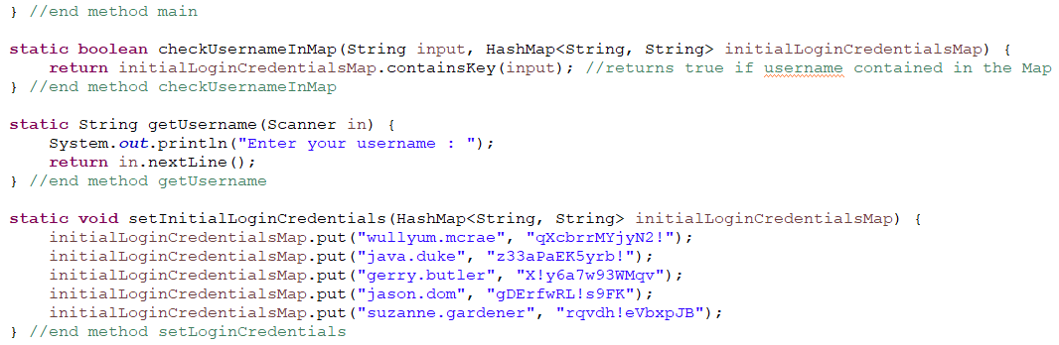

Figure Developing the log in system

To test the logic of logging in, a do while loop was used to prompt for user input until their username is found:

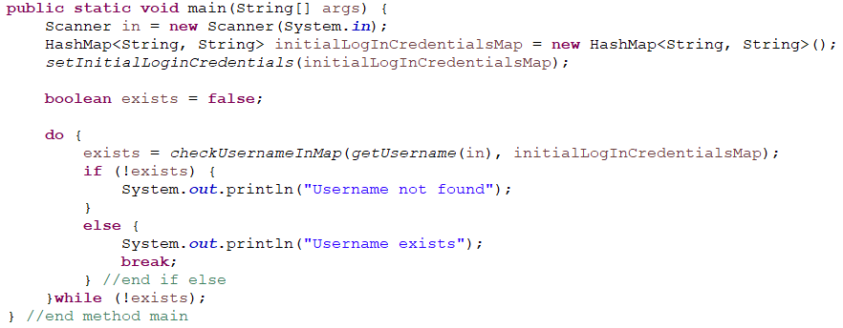

Figure Log in step 1 - get the username

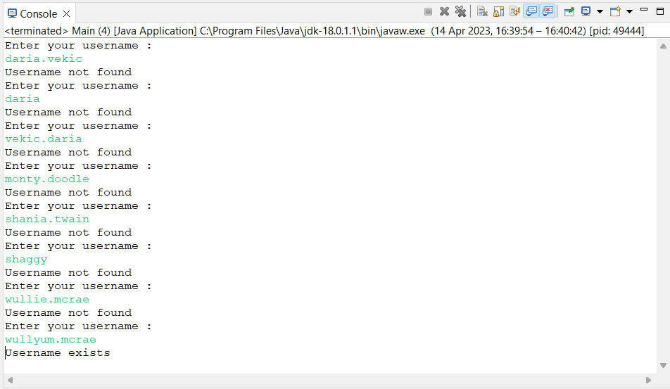

Figure Log in step 1 - testing results

The next step was to receive the user’s password and check if their input is the corresponding Value to the username. In other words, does the Value match the Key in the HashMap?

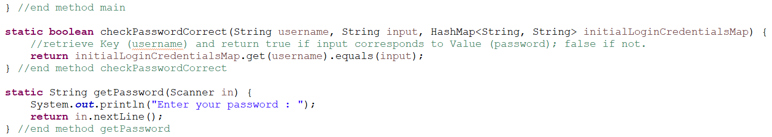

Figure Log in step 2 - check the password matches

To test this logic, a nested do while loop was added to prompt for the password after a valid username is received:

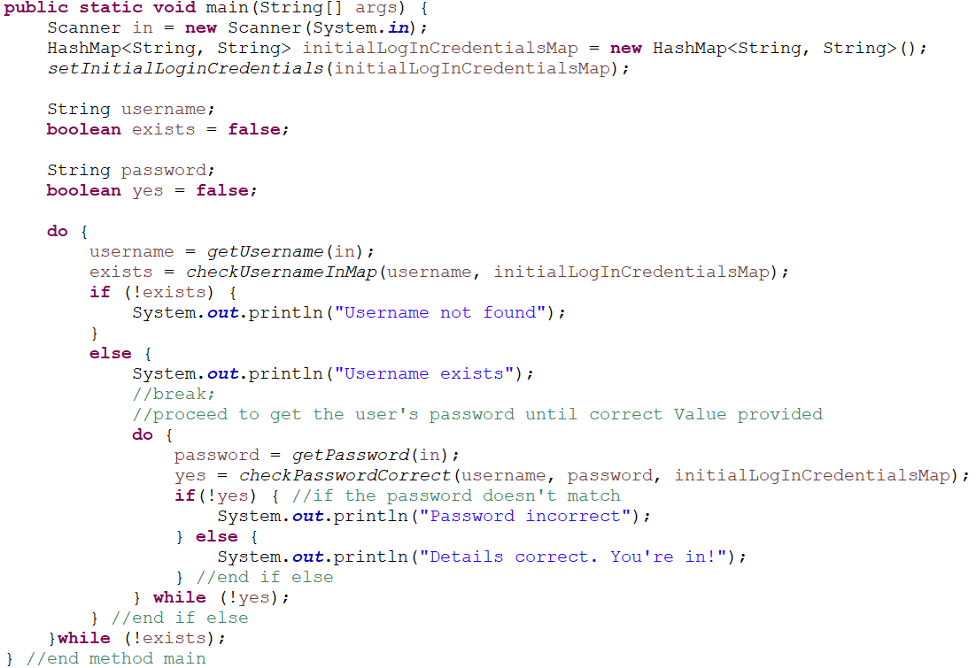

Figure Log in step 2 - check password matches

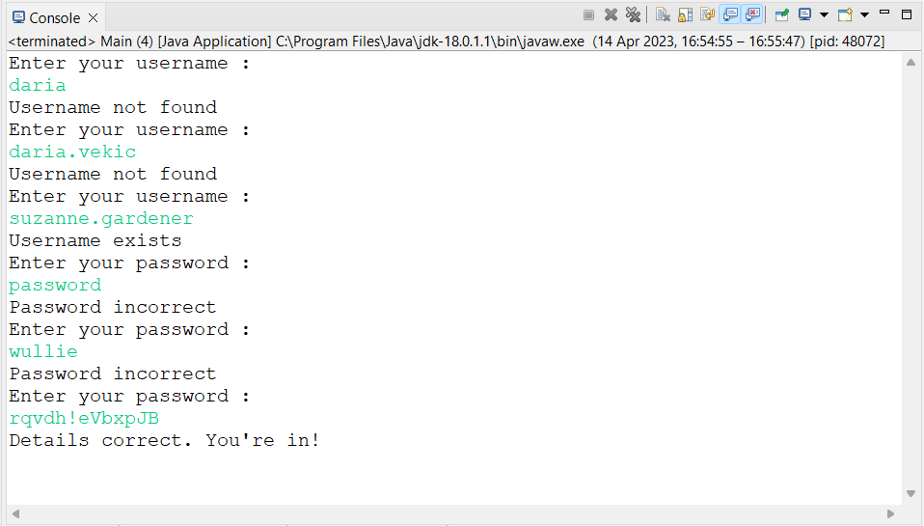

Figure Log in step 2 - testing results

As the background context of this project is a case management system for a work environment, it’s not a business requirement for the employees to be able to change their username. However, we do know an employee will have to set their own password at some point. Most workplaces will provide an initial password to their employees but it's common for the employee to be able to change their password to something more memorable. They're not going to change their username because that's stipulated by business rules to be an employee's first name, a dot, and their last name (hence why the username is used as the Key in the Map). There’s no need to create a completely new HashMap. We just have to **replace** the Value. It makes sense to rename the HashMap to loginCredentials rather than initialLoginCredentials at this point as well:

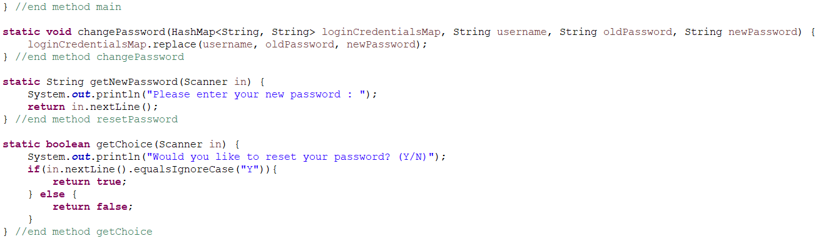

Figure Log in step 3 - ability to set a password

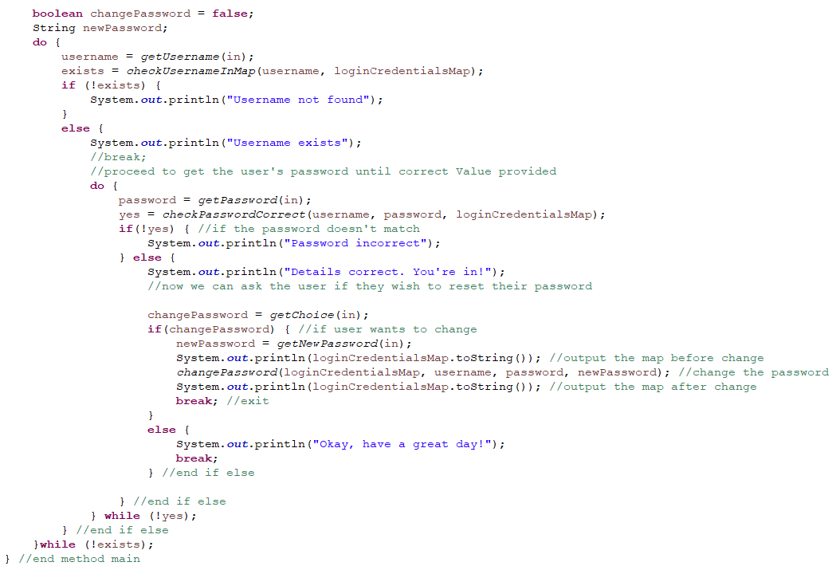

Figure Log in step 3 - user can change password

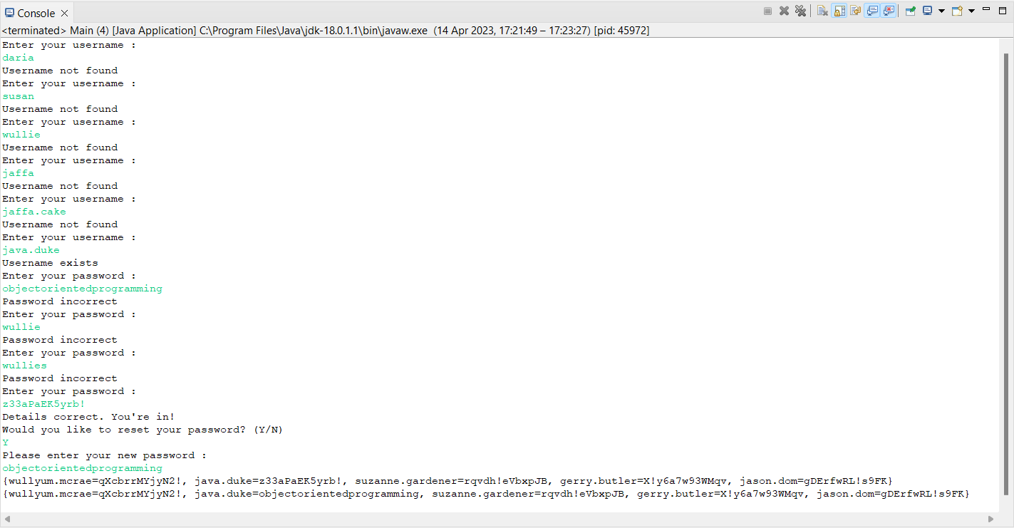

Figure Log in step 3 - testing results

#### New Password Validation

From the output above, we can see that the password for java.duke has been updated to objectorientedprogramming. So the mechanics of changing a user's password works. But we know that in this project, the client has specified their desired minimum criteria for a password. So we have to devise an algorithm that checks a user's new password meets this criteria. The client has provided a criteria that makes for a very secure password:

* 12 characters;
* must include special characters;
* 1 number; and
* and 1 uppercase character.

Given I spent a fair amount of time earlier trying to devise validation methods and then ultimately proceeded to use regular expressions, I first started by trying to come up with a regex that checks for the above criteria. Rather than cramming a lot of rules into one regular expression, it might be better to try and split the regular expression up.

We can easily check for the length by using the .length() method.

To check for special characters, we first have to consider what special characters should be included in the regex. Considering the context, employees logging in to a case management system, they will be using a QWERTY keyboard, so it would be sensible to include special characters that are included in a typical QWERTY keyboard. **Mention this to client in next meeting just to confirm it's ok.** We can check for special characters with this regex taken from Java Code Examples:

"[~!@#$%^&*()_+{}\\[\\]:;,.<>/?-]"

(Java Code Examples, 2021)

We can check for one number anywhere in the password by combining repetition operators. We need the user's password to contain a digit, but it doesn't matter where that digit occurs, so if the dot represents any character and the asterisk represents any number of occurrences of the character preceding it, then ".*\\d.**\***" will return true if a digit or any number of digits is found:

".*\\d.*"

And finally to check the password contains at least one uppercase character, we can use the same approach but replace \\d with the range [A-Z].

So to validate the user's input for a new password, we end up with a method like this that is invoked after we receive the user’s new password:

Figure Password criteria validation

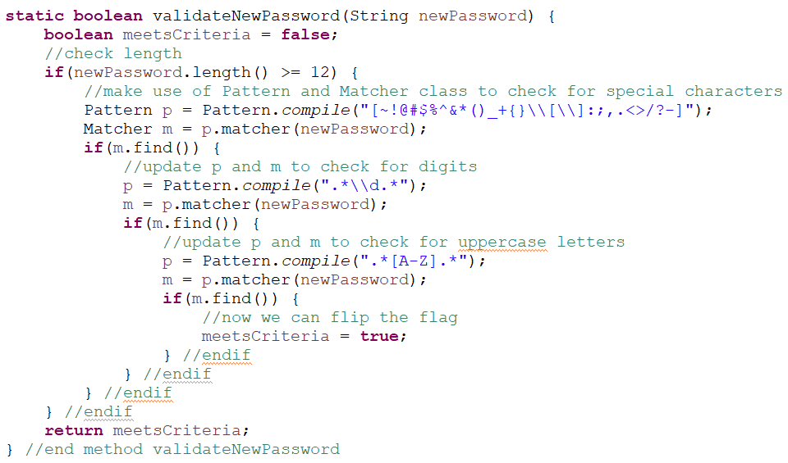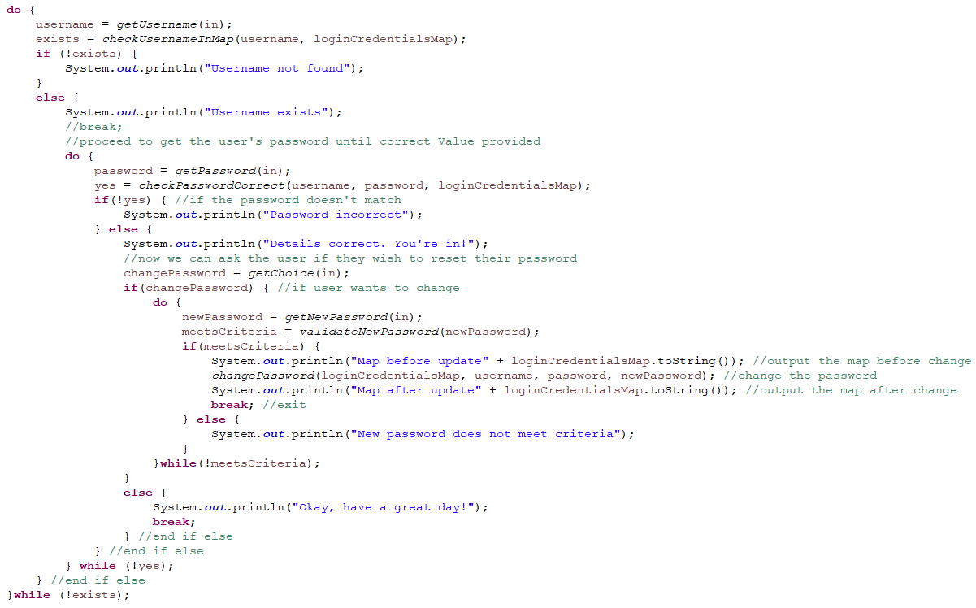

Figure Log in step 4 - check new password meets criteria

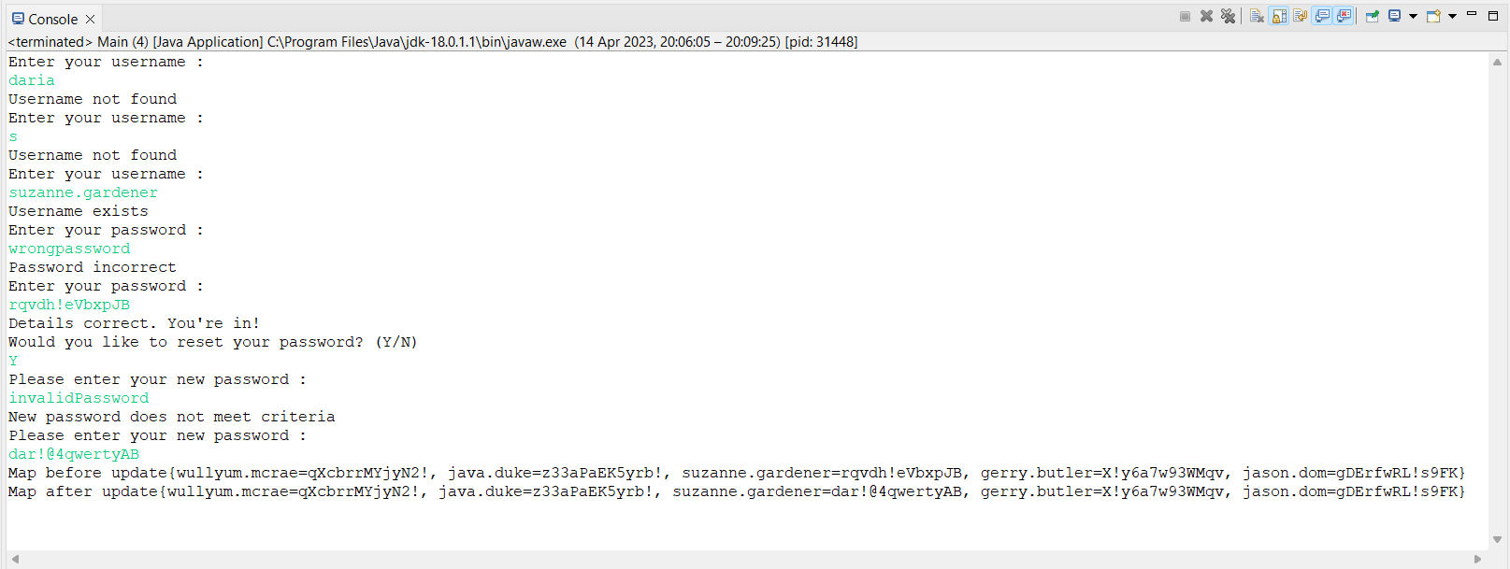

Figure Log in step 4 - testing results

#### Password Hashing

We know it's definitely not secure in any way to store a password as a String value. So far I have been trying to break the whole log in process down into more manageable steps. But in reality, a password will go through an algorithm to be hashed, and it is the hash that is stored in the back-end; not the password in plain text.

This has required some additional research to implement. We have been taken through some password security lessons in units HF5834 Web Essentials and HF5735 Dynamically Generated Content of this course, but this was primarily from the angle of website development. It is not something that we have explored or implemented in the context of a Java program.

The client provided a good selection of password criteria to begin with (min 12 characters, at least 1 special character, number, and uppercase character). But why does this make the password stronger? This nice infographic taken from cloudnine.com suggests the longer the password is and the more varied its contents, the harder it is to reveal its plaintext value using its hashed value:

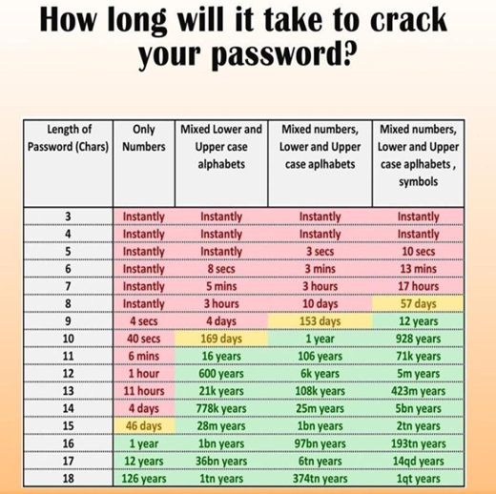

Figure Password security infographic (CloudNine, 2020)

The cryptographic hashing process is what determines how secure a user’s password is. It can be looked at as a means of defence, as Martin Paul Eve suggests in Chapter 3 of *Passwords*:

…there is a determinate place where a computer is storing your password whenever you login so that it can be checked. In contrast to a human-to-human interaction, though, when computers store information it is *susceptible to interception* by others. … Like the wizards attacked by mind readers in the world of Harry Potter (a ‘Legilimens’), computers are *vulnerable to external penetration*. Along with other defences, this is where systems of cryptographic hashing enter the equation. (my italics) (Martin Paul Eve, 2020)

So, if McRae&Dick’s new system were to be attacked, their password criteria combined with a hashing algorithm means it would **potentially** take 5 million years to crack (ain't nobody got time fo' that!). But that depends on the qualities of the hashing algorithm. I've never attempted to program a log in system in a Java program before, but given that a strong contender to be used in our Web Development class was BCrypt, I wanted to explore implementing this algorithm in a Java program.

##### Hashing Algorithm Properties

There is more than one hashing algorithm available to use. According to Sam Millington, there are four key qualities a hashing algorithm should possess in order to be described as secure. These are:

* **deterministic**, meaning the algorithm should always result in the same hash value given the same message value;
* **irreversible**, meaning the algorithm will generate one output given one input, but will not reveal the input given the output. This property is an extremely important aspect of hashing algorithms. It is, in other words, a one-way street – this is the key difference between hash algorithms and encryption: encrypted messages can be decrypted.

For example, you write a message to someone on WhatsApp. You know what the contents of the message are. You press send. The message is encrypted on its travels to the recipient. It arrives at the recipient's address. The recipient reads the **decrypted** message. In fact, WhatsApp's Help Center states: "Before a message ever leaves your device, it's secured with a **cryptographic lock**, and only the recipient has the **keys**. In addition, the keys change with every single message that's sent" (faq.whatsapp.com, n.d.).

In password hashing algorithms, there is no key to unlock the password because the process is not reversible;

* **unpredictable**, with a high level of entropy, meaning a very small amendment to a password should result in a completely different hash value; and
* **collision‑resistant**, meaning two different inputs should not result in the same output. (Millington, 2018)

#### SHA-512

It's common for personal devices to hold a decent level of power now, meaning that home computers can often cope with a high work volume and perform many tasks at once. As personal computers become more powerful, password hashing algorithms have to be strengthened. The Secure Hash Algorithm has been a commonly used hashing function since 1993, but has evolved since them when weaknesses have been discovered. The SHA‑256 and SHA‑512 function is remarkably stronger than SHA predecessors – they produce hash values that are 256 and 512 bits respectively and "use different shift amounts and additive constants, but their structures are otherwise virtually identical, differing only in the number of rounds" (Wikipedia Contributors, 2019). In terms of implementing this in a Java program, it is one of the strongest hashing algorithms available through the MessageDigest class in the java.security package:

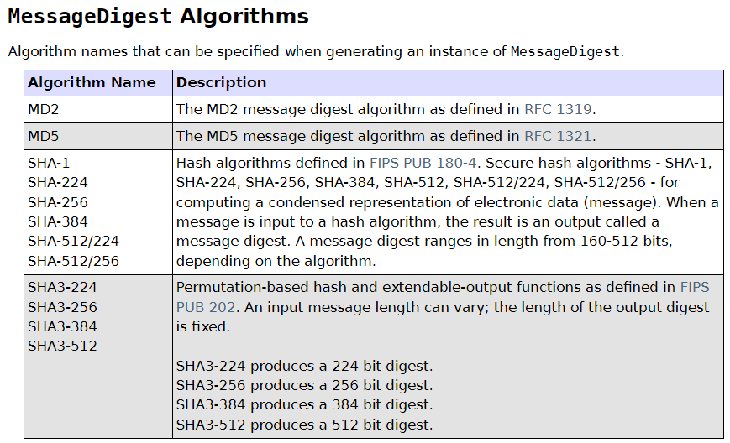

Figure Algorithm selection to use with MessageDigest (docs.oracle.com, n.d.)

It's very often frowned upon when a SHA is used to hash a password. However, in Java it is also possible to generate and add a salt to the hash value. This enhances the algorithm's entropy quality, to hark back to Millington's four key characteristics of a good hashing function: a salt is a random sequence of characters is generated and added to the user's password. This makes the uniqueness of the hash value more reliable: if two users use the same password, it doesn't throw up any security problems because the salt will mean each password is unique and therefore result in two completely different hash values.

These steps are important for developers to implement to prevent data being compromised. The uniqueness slows down brute force attacks and dictionary attacks significantly, as it takes longer to guess every password combination and find a match. If the password does not have a salt value added, attackers can easily carry out a rainbow table attack where a large collection of the decrypted values of hashed passwords can be searched in order to locate a given hash. If a salt value is generated and added to each user's password, then a rainbow table would have to be created for every salt (Security, n.d.).

With this in mind, it left me in no doubt that I should attempt to implement generating and adding a salt value to a user's password. To do this in a Java program, an instance of the SecureRandom class has to be constructed. This class is also part of the java.security package and extends the Random class:

This class provides a cryptographically strong random number generator (RNG).

A cryptographically strong random number minimally complies with the statistical random number generator tests specified in FIPS 140-2, Security Requirements for Cryptographic Modules, section 4.9.1. Additionally, SecureRandom must produce non-deterministic output. Therefore any seed material passed to a SecureRandom object must be unpredictable, and all SecureRandom output sequences must be cryptographically strong, as described in RFC 4086: Randomness Requirements for Security.

(docs.oracle.com, n.d.)

It doesn't seem like a fair argument to make that SHA‑512 should absolutely never be used to hash a plaintext password. If this is combined with the use of generating and adding a salt value, it's far better than not using any hashing algorithm at all. To test implementing this, it's quite simple and doesn't require much code:

Figure Java implementation of SHA-512 hash algorithm with salt

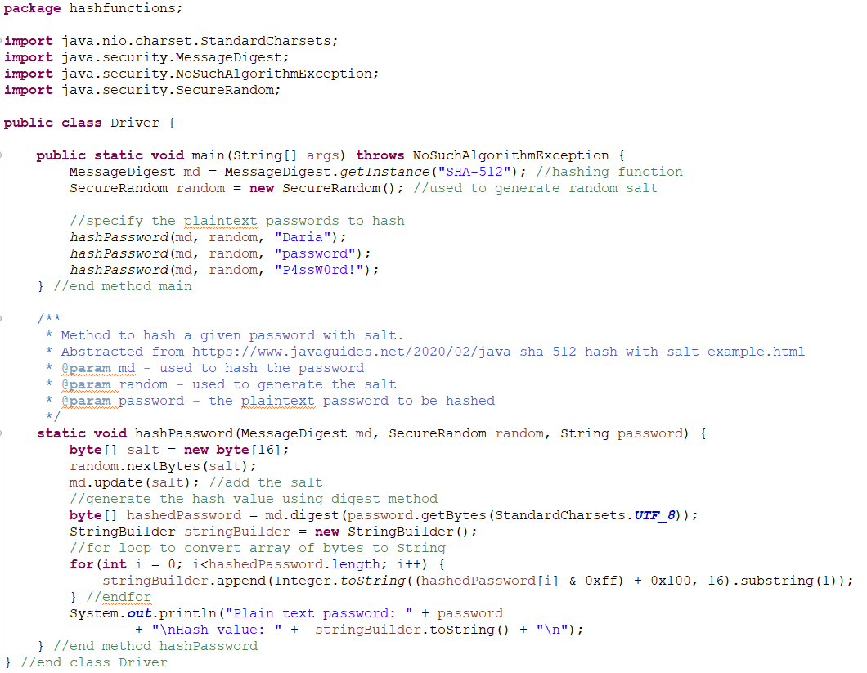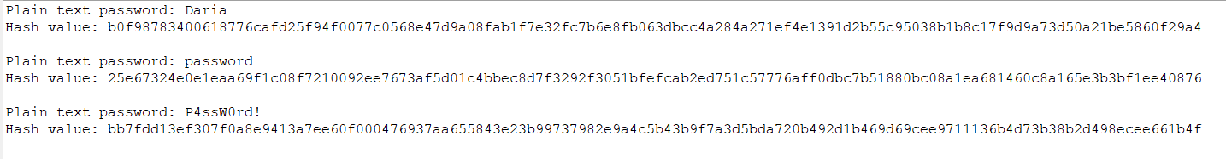

Figure Plaintext and hashed password values

#### BCrypt

Millington also emphasises that a hashing algorithm should be slow in terms of processing time. This is because if the algorithm processes information quickly, it means an attacker would be able to discover users' passwords much more quickly and easily, and obviously the client will want to avoid serious data breaches. So in addition to the four qualities mentioned earlier, a better hashing algorithm is one that is slow enough to mitigate attacks, but quick enough to not cause too much delay for the user.

There are other hashing functions available that are considered "slow". Obviously a log in system requires some decisions to be made to ensure security. As mentioned, I wanted to explore how to implement the BCrypt hashing algorithm in a Java program, as this is an algorithm that has been designed for the purpose of hashing passwords (Cryptoguiding, 2023). BCrypt brings the advantage of being able to configure the strength myself by specifying the number of rounds – the higher the number of rounds, the slower the hashing process is; the slower the process is, the harder it is for an attacker to access users’ plain text passwords. A “round” refers to one iteration of changes to the given message; one change results in a new hash value. This is what makes an algorithm collision‑resistant: a small change results in a very different and difficult‑to‑guess hash value. So if a salt value is simply a sequence of random characters to ensure uniqueness of a plaintext password, and a salt goes through several iterations of changes (rounds), this results in a message that is very different to the plaintext String the user enters. Even if two users have the same password, the two values that are going through the hashing process are actually very, very different, and of course the higher number of changes (rounds) the value goes through the slower the algorithm will work. If the process is slow, then an attacker can hash far less potential plaintext passwords per second in a brute‑force or dictionary attack and thus it takes significantly longer to discover the real password. This means that as hardware becomes more powerful, using BCrypt makes it quick and easy to strengthen data security by increasing the number of rounds etc.

There’s no obvious way to configure the number of rounds a SHA-512 algorithm goes through. In developing the LogInController class, a decision had to be made in relation to which password hashing algorithm should be used. To test the nature of each algorithm, I created a separate Java project, the code for which I have **submitted in PDF format** to avoid cluttering this report (file “**hashfunctions.pdf**”). Some snippets are shown below, which demonstrate the hash value of the same plaintext password for each hashing function (Figure 72 already shows how implementation of SHA-512 in Java):

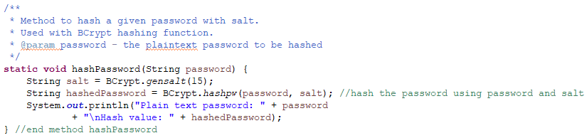

Figure Method to hash password using BCrypt, salt rounds set to 15

To test the speed of these hashing functions, I have made use of System.nanoTime() which returns the “most precise available system timer, in nanoseconds” (www.tutorialspoint.com, n.d.)[5]:

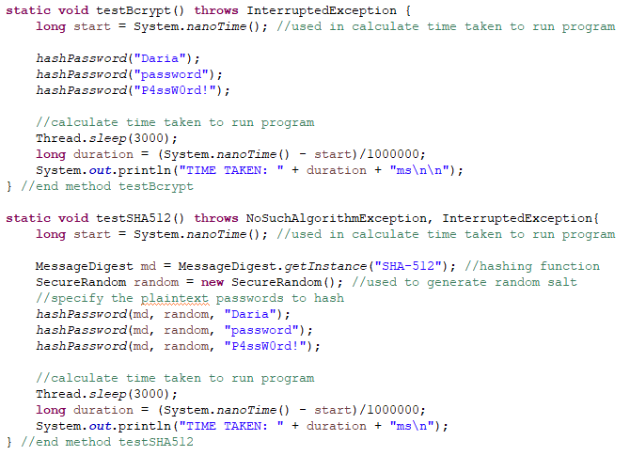

Figure Methods to test hashing of passwords and calculate time taken for each

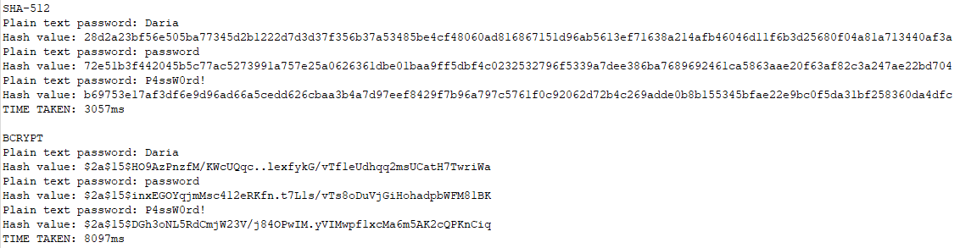

Figure Output when test methods are run

Clearly, the slower hashing function is BCrypt. There is a significant difference in the speed of SHA-512 and BCrypt, with SHA-512 taking 3057ms to hash three simple messages and BCrypt taking 8097ms to hash the same three messages when the number of iterations of salt generation (salt rounds) is set to 15. Furthermore, if we run one of these messages through a hash speed test using [Hash Speed Test (asecuritysite.com)](https://asecuritysite.com/encryption/htest), the same conclusion can be drawn:

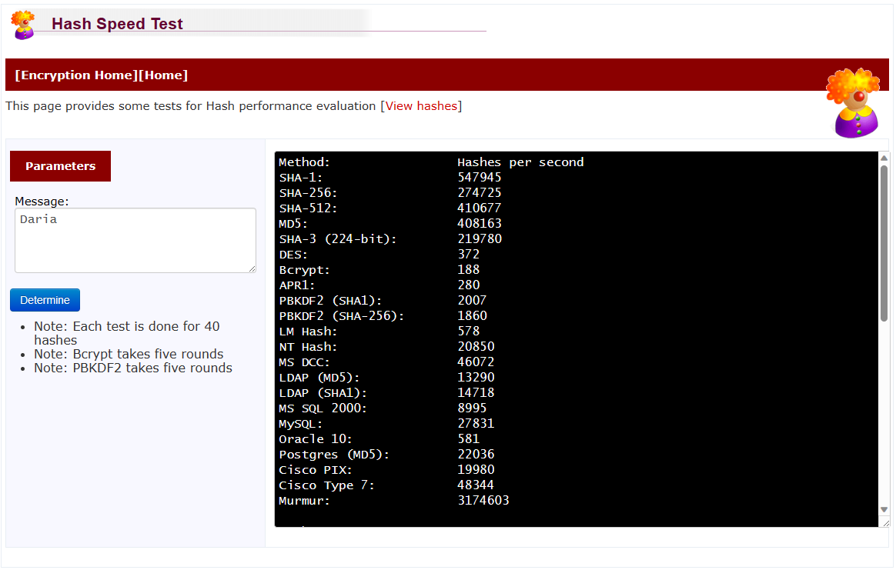

Figure Hash speed test

This useful site also provides a ranking of hash function speeds:

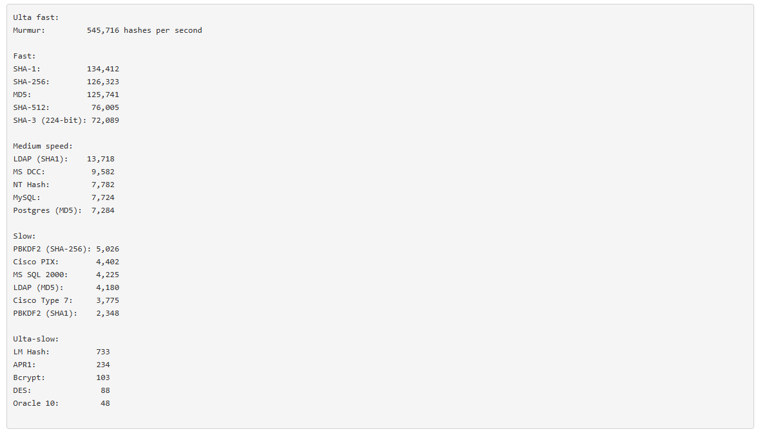

Figure Hash function speed rankings, taken from https://asecuritysite.com/encryption/htest

Remarkable difference in speed between SHA-512 and BCrypt

Although it’s really clear that BCrypt is winning in the battle of hashing algorithms in this project, I wanted to take this opportunity to explore ethical hacking more given password cracking wasn’t a major part of our Ethical Hacking unit in this course.

**Disclaimer: This was mentioned to the client who was agreeable to this, and this was only carried out to gain some practical experience of the strengths of BCrypt. I promise I will never do anything unethical.**

### Password Cracking

#### Virtual Machine Settings

After setting up a virtual machine using Oracle VM VirtualBox and installing Kali Linux and Ubuntu, I set the motherboard and processor settings of the virtual machine as follows:

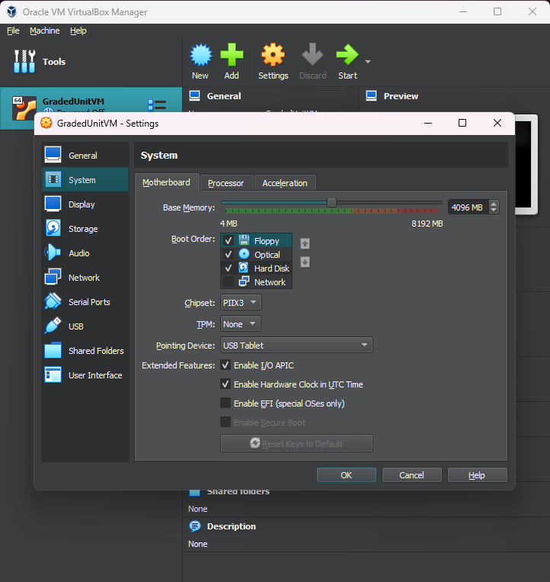

Figure Virtual machine motherboard settings

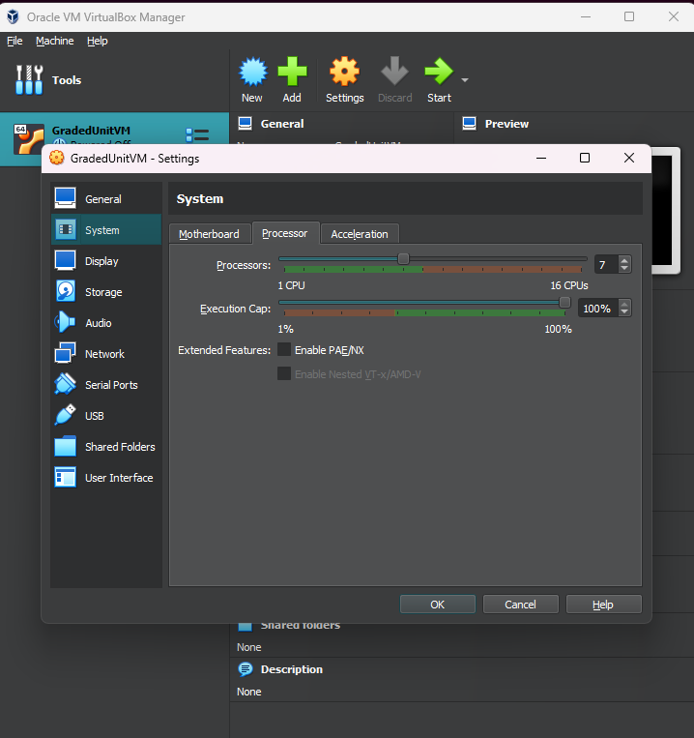

Figure Virtual machine processor settings

The above settings give the virtual machine a healthy level of resources to carry out the attack. At client meeting number 5, the client tested the resetting password functionality, giving me the chance to attempt to crack the new password using the hash value only. The salt rounds are set to 10 in the Graded Unit project (a balance needs to be found so the user isn’t waiting an excessively long time to log in to their system). In Kali Linux, the tool hashcat, which comes installed with Kali, allows the user to specify what hashing function they wish to run the attack with:

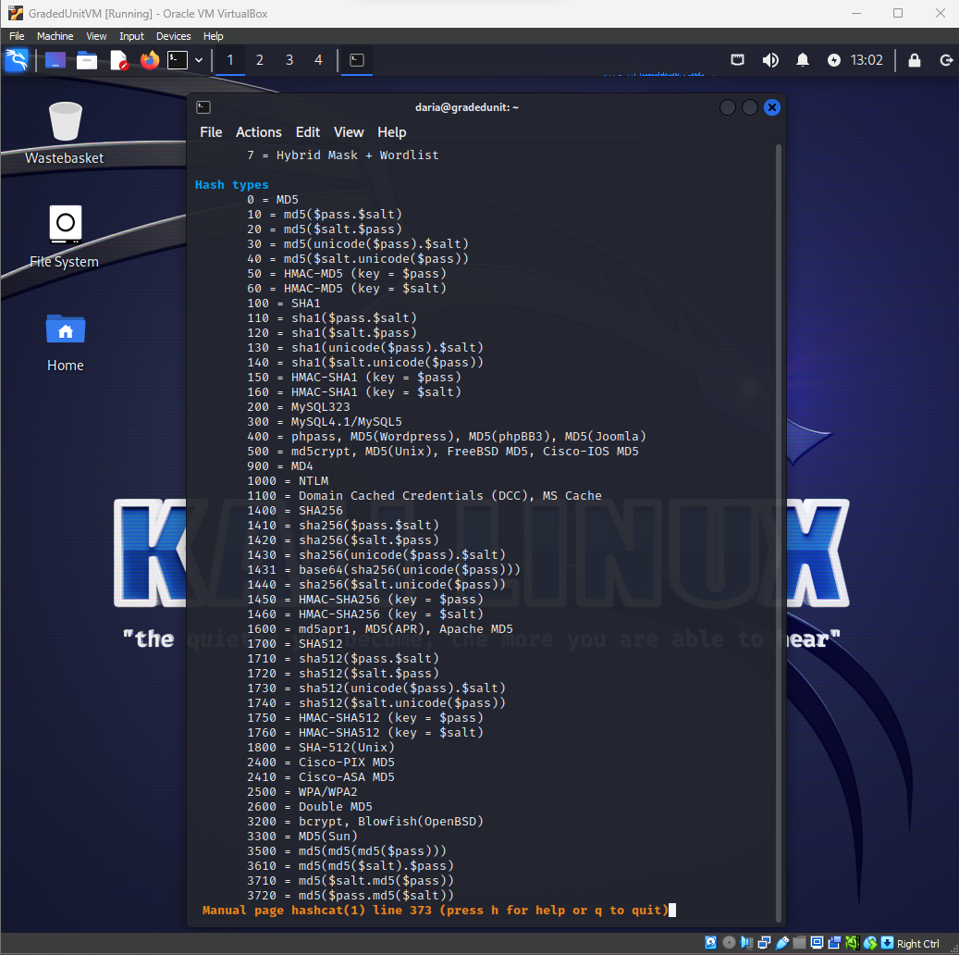

Figure Hashcat available hash types

So in this case I know I’ve used BCrypt, so this is specified through the command -m 3200 (see Figure 84). The wordlist “rockyou.txt” was downloaded and unzipped to be used in this attack:

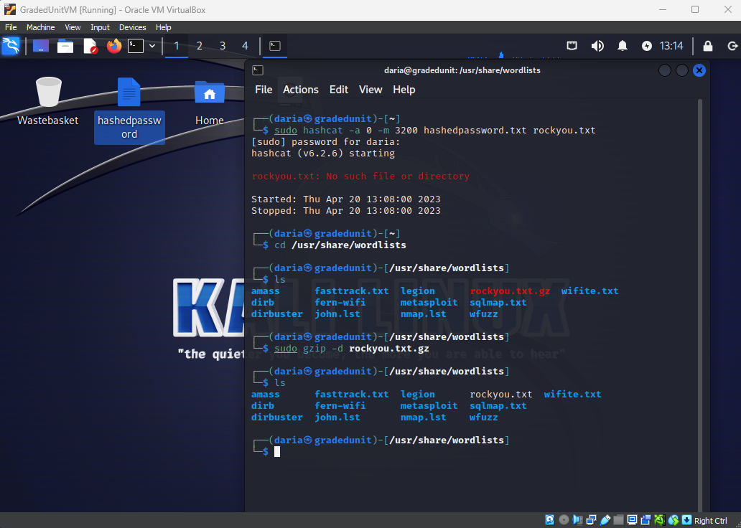

Figure Unzipping rockyou.txt

A text file “bcrypt.txt” was created and the hash value of the reset password was inserted into this file. An empty text file “cracked.txt” was created, intended to store the result of the attack (the cracked password) if successful. The wordlist rockyou.txt was the list of plaintext passwords the attack used to check against. Hashcat offers the following attack types:

Figure Hashcat attack types

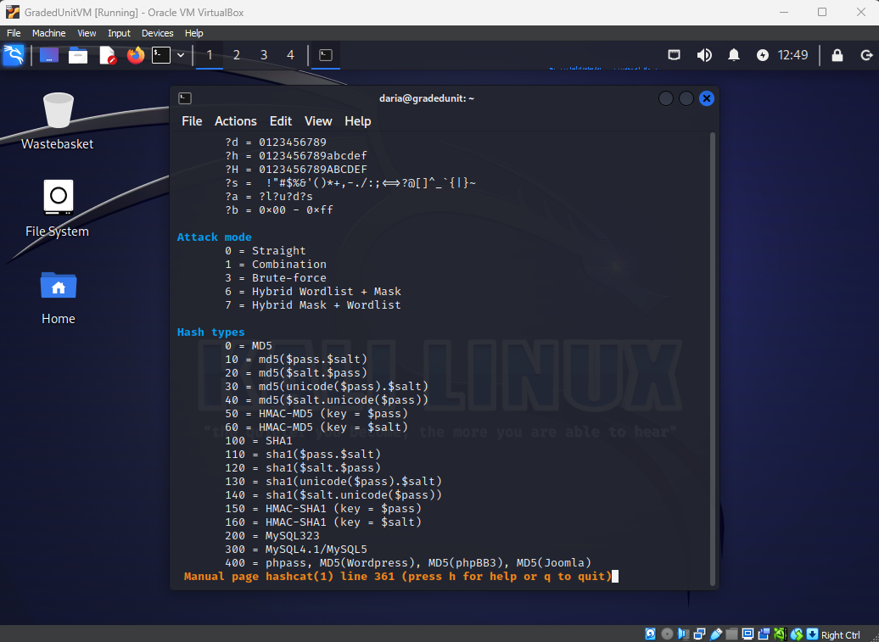

So, to specify all of this information and to specify I want to attempt a dictionary attack, the command is as follows:

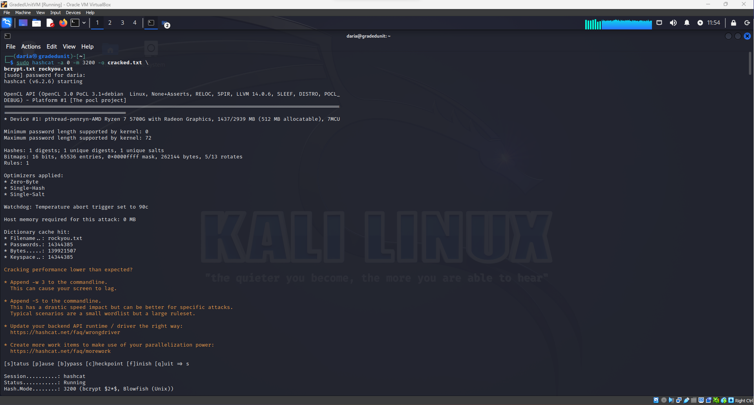

Dictionary attack using BCrypt

Figure Command to start dictionary attack using hashcat

There is then a short status report:

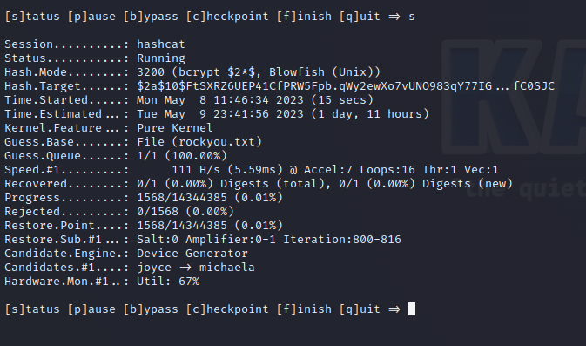

Figure Hashcat attack status report

From Figure 85 the hashcat tool indicates that it estimates the full attack will take 1 day and 11 hours to complete. After leaving hashcat running for about 4 hours, the updated status report is as follows:

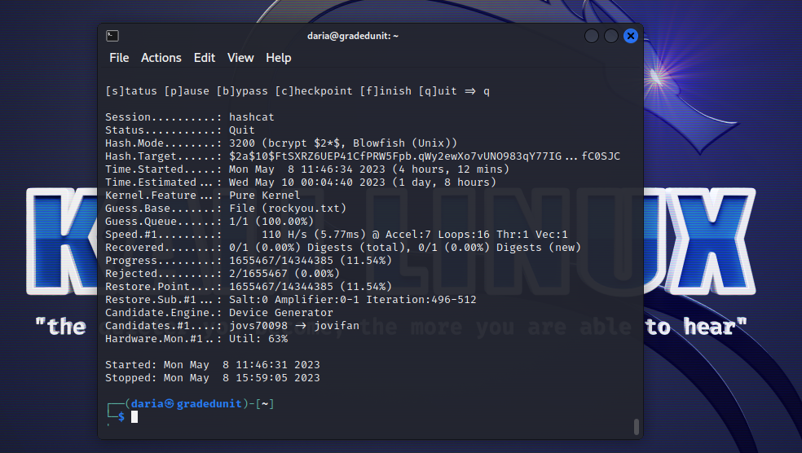

Figure Hashcat status report after 4 hours

After several hours the attack has only progressed through slightly more than 10% of the wordlist. This shows that if the project implements password hashing using BCrypt, generates and adds a salt, and requires users to set their password to a minimum criteria (see New Password Validation), then we are taking the right steps towards implementing a secure system for the client that will be robust even as hardware advances and becomes more powerful. The number of rounds a salt generation goes through determines how hard the hardware has to work – more rounds means more work: “[i]ncreasing the cost factor [the number of rounds] by 1 doubles the necessary time” (Cryptoguiding, 2023). So with this in mind, I intend to keep the salt rounds set to 10 to maintain a balance for the user: it’s not ideal to be waiting a long time to log in to a system in a workplace, but it is ideal for any kind of data to be kept as secure as possible.

## Client Meeting 5

### Client Meeting Agenda

The following agenda was prepared and issued to the client in advance of meeting number 5.

**Meeting 5 to be held at 09:10 on 19/04/2023**

**Falkirk Campus, Forth Valley College**

|  |  |
| --- | --- |
| **Present:** |  |
|  |  |
|  |  |
| **Apologies:** |  |
|  |  |
| **Chair:** |  |
| **Minute Taker:** |  |

1. **Minutes of Previous Meeting**

N/A

1. **Matters Arising**

N/A

1. **Short Demo (3 mins)**

A short demonstration of use cases Log In and Add New Case using normal data.

1. **Data Rules (2 mins)**

A few data rules need to be clarified.

Case Description – do you want a maximum limit of characters placed on this input? It currently only checks that this field is not empty.

Max length of a client name when adding a new case (I have set this to 25 but would like confirmation).

Postcode – confirm the user should be **required** to enter a space as a separator. Would you like the user to be able to enter a postcode **without** a space? Should the system be able to accept PO Box addresses?

Phone number – Should the system allow for international dialling codes? It currently only accepts mobile and landline phone numbers.

Password criteria rules – established in meeting 1 a password should contain at least 1 special character. Does this refer to special characters that appear on a QWERTY keyboard only?

To allow your employees access to the system for the first time I have set pre-defined passwords. You must emphasise to your employees that it is more secure for them to reset their password asap to something they will remember. This way their password will not be stored in plain text anywhere.

1. **Changes to Design (2 mins)**

A few changes have been made during implementation.

When logging in, I have removed the default text from the password field to make use of a more secure software component (JPasswordField). I have also changed the text displayed in the link on the Log In interface. It now looks like this:

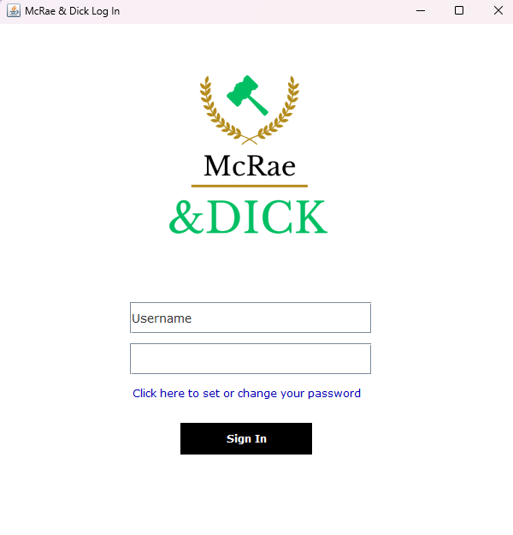

Removed default text here in order to make use of JPasswordField – more secure than using a JTextField.

Changed the text displayed in link to allow current employees to change their password if need be.

Please confirm if you are happy with these changes.

I have also tweaked a few error messages which I believe will be far more helpful to your staff. Instead of the original error message “Invalid log-in details entered!” I have added an error message for an incorrect username / incorrect password separately:

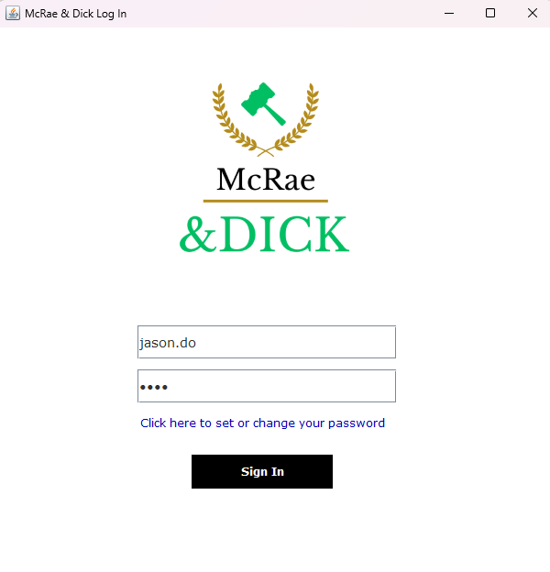

Incorrect username

Correct password

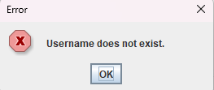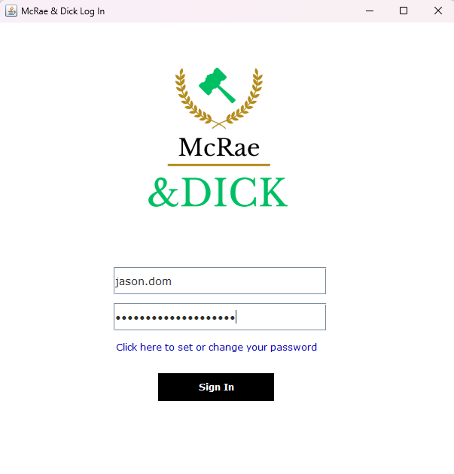

Correct username

Incorrect password

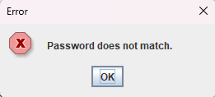

1. **Resetting a Password Demo (3 mins)**

I have implemented functionality to allow any employee to change their password.

Please confirm if you are happy with this.

1. **Date of Next Meeting (<1 min)**

To be confirmed.

### Client Meeting Minutes

The following meeting minutes were prepared after the fifth client interview.

**Meeting 5 held at 09:10 on 19/04/2023**

**Room 0.021, Falkirk Campus, Forth Valley College**

|  |  |
| --- | --- |
| **Present:** | Daria Vekic (DV), Project Manager |
|  | Susan Gardner (SG), Client |
|  |  |
| **Apologies:** |  |
|  |  |
| **Chair:** | Daria Vekic (DV), Chairperson |
| **Minute Taker:** | Daria Vekic (DV), Minute Secretary |

1. **Minutes of Previous Meeting**

N/A

1. **Matters Arising**

N/A

1. **Short Demo**

A short demonstration was shown to the client after a few technical issues. Demonstration highlighted a couple of areas for review, in particular the error messages displayed when adding a new case. **Action point: DV to review all error messages and validation routines.**

1. **Data Rules**

Case Description – Client happy with this as is. No upper limit needed.

Client Name – current length (between 1 and 25 characters) is fine.

Postcode – client would like the ability to enter a postcode **without** a space separator. **Action point: DV to update regular expression.** Client confirmed there is no need to allow for PO Box addresses.

Phone number – system is not required to allow for international dialling codes.

Password criteria – special characters refers to QWERTY keyboard. No need to update this validation.

DV highlighted that the system will come with pre-set password values and staff will be reminded it is secure to reset their password.

1. **Changes to Design**

DV proposed a few minor changes to the design. Client is happy with the adjustments made to the design.

1. **Resetting a Password Demo**

Client is happy with having this functionality to allow any employee to reset their password. Client tested changing password.

1. **Date of Next Meeting (<1 min)**

To be confirmed.

## The User Interface Domain

Earlier in this report the benefits of adopting the Model, View, Controller organisational technique are discussed (see section What Now?). Figure 48 shows the package structure of the project, with package View containing classes that are primarily responsible for creating user interface elements. In this current iteration of development, the View package now contains 6 classes:

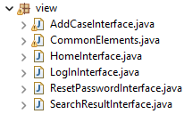

Figure View package

I don’t think these classes need much further explanation. For example, the class AddCaseInterface is constructed when the user presses the “Add New Case” button. The class CommonElements has been included to include code implementation of elements that are present at all times, or that are commonly used in the View section. More specifically, this class contains a method to construct the navigation menu that includes the search bar and search button. Its main purpose is to reduce the verbosity of code in other View classes, so the method shown at Appendix 2 isn’t repeated in several classes. It also registers the required ActionListeners along with the corresponding ActionPerformed methods. For example, when the user presses the “Add New Case” button in the navigation panel, the system knows to follow the routine at the ActionPerformed method:

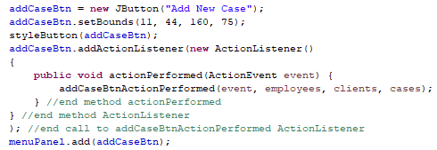

Figure Registering ActionListener

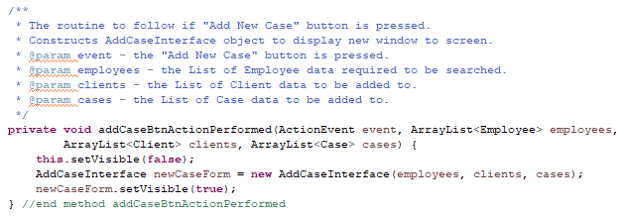

Figure ActionPerformed method defines instructions when a given action is performed

It also contains instance fields for access to the Controller classes:

Figure Instance fields to access Controller classes



### WindowBuilder

When developing the View model of this project, I initially looked into using WindowBuilder. My reason for this was that I wanted to free up time to think more of the functionality of the system including how and where data input would be validated, stored etc. The idea of being able to drag and drop Java Swing components seemed appealing as manually coding interface components can get quite tedious. The Eclipse IDE website offers a user guide for WindowBuilder, and describes it as a,

powerful and easy to use bi‑directional Java GUI designer that makes it very easy to create Java GUI applications without spending a lot of time writing code to display simple forms. With WindowBuilder you can create complicated windows in minutes. Use the visual designer and Java code will be generated for you. You can easily add controls using drag-and-drop, add event handlers to your controls, change various properties of controls using a property editor, internationalize your app and much more. (help.eclipse.org, n.d.)

The really beneficial aspect of WindowBuilder is it’s effortless to resize components and position them. It makes it far less frustrating when you can see where the components are rather than having to visualise position coordinates and sizes. It’s also very simple to change the scope of a component variable. For example, if I include a component that I realise later needs to be used throughout the class, there’s a handy button that changes the variable from class level to local (or vice versa):

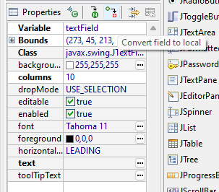

Figure WindowBuilder variable scope changer

Similarly, the variable name and properties can be set easily. To change its name, you simple click inside the “Variable” value box and set its value to something more appropriate.

I would argue WindowBuilder isn’t as powerful as it’s claimed to be though. It’s great if the GUI is simple and contains minimal panels and mainly labels and text fields as it can be built in a really short space of time. The ability to rename variables and set properties through a GUI is nice, but in reality it’s not that time‑consuming to do this manually. For example, if I want to set the text to be displayed on a JButton, I only have to type the name of the button, press the “.” (dot) key, and the IDE presents a list of available methods to me, from which I can simply locate the method I need and hit “enter”. I don’t see how doing this through a GUI makes it powerful. Even when adding ActionListeners, WindowBuilder simply presents you with the source code where the ActionListener has been added, so yes it generates code but at some point you’re going to have to spend time in the source code which gets a bit messy when you’ve included quite a few components in no particular order.

When trying to create GUIs that are slightly more complicated, WindowBuilder doesn’t seem to be able to cope. For example, when trying to include a JTable component, the WindowBuilder “Design” tab wouldn’t open. After some frustration I decided to sack the idea of using WindowBuilder for anything that used components other than labels, buttons, and text fields, instead reverting to manually coding components still to be added and tweaking position coordinates and sizes. I didn’t record any screenshots of WindowBuilder errors or flaws to avoid wasting time and effort. It also doesn’t encourage learning: if you’re new to Java and building Java GUIs, opting to use WindowBuilder from the start wouldn’t teach you about what methods do or any technical elements of the GUI – it just requires you to drag a component and drop it somewhere, therefore requiring little thought (which is good on an off day, but not overall).

Overall WindowBuilder is useful for building simple GUIs. It’s best for building the bare bones of the GUI, but for adding any real detail and functionality, it’s far better to just write the code. It certainly doesn’t improve organisation of the program because components are constructed and set in the order you drop them in the “Design” page. So if you add some text fields, some buttons, then more text fields, some labels, it can result in spending more time trying to clean up the generated code.

### Design Matching

After trying out WindowBuilder and programming the GUI needed for this iteration of development, the actual solution matches the design to a large extent, with a few minor changes that have been addressed with the client (see Client Meeting 5). The client was given a short demonstration in this meeting, and no objections in relation to the GUI were raised. The following screenshots show the design provided in Solution Planning and the user interfaces in the actual solution.

#### Log In

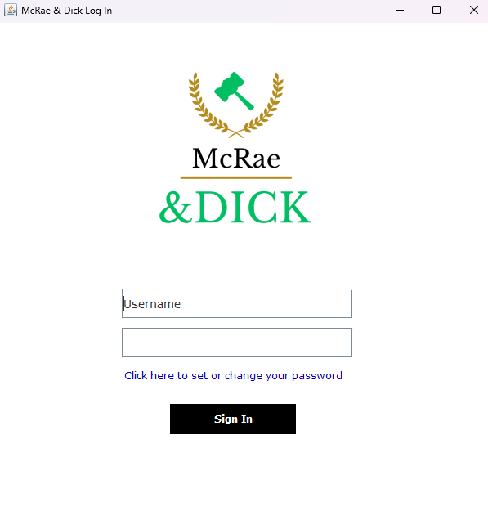

**Actual user interface**

Figure Actual Log In user interface

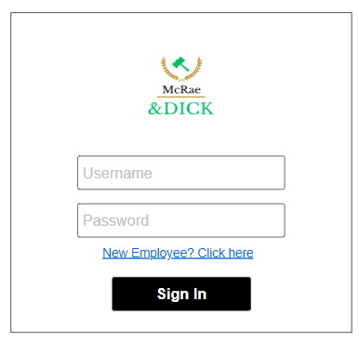

**Solution Planning design**

Figure Solution Planning Log In design

#### Home

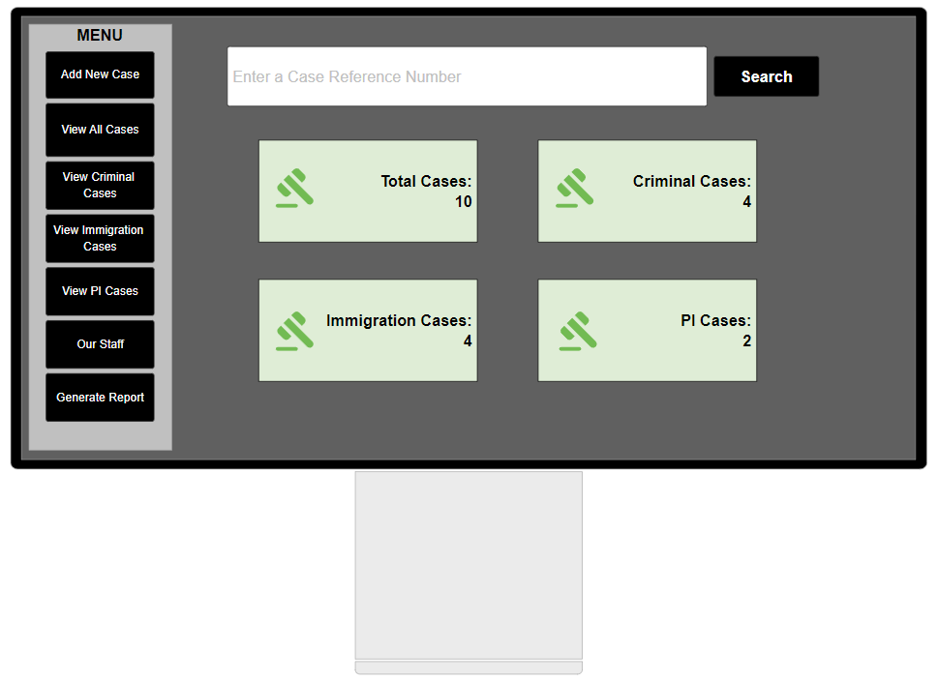

**Solution Planning design**

Figure Solution Planning Home design

**Actual user interface**

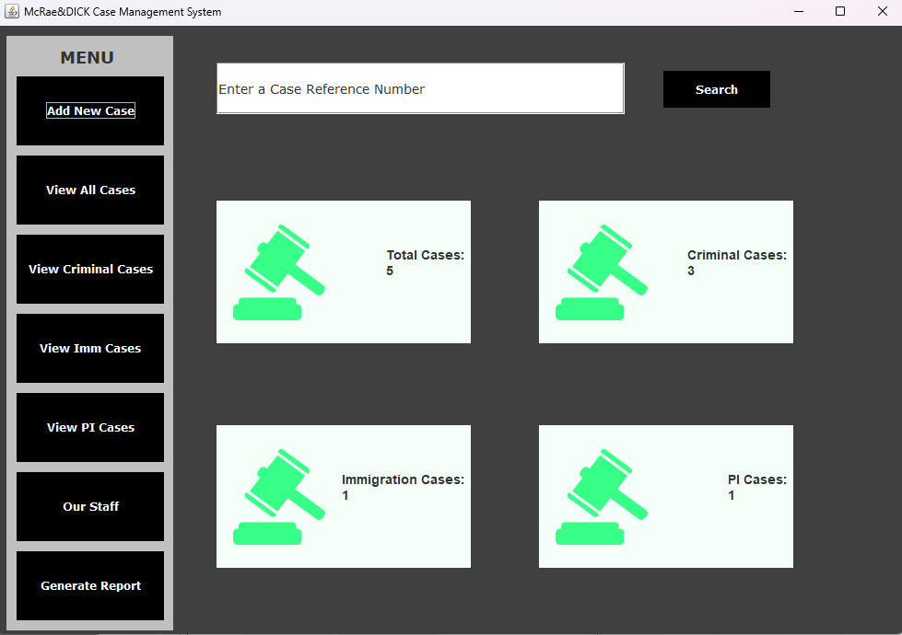

Figure Actual Home user interface

#### Add New Case

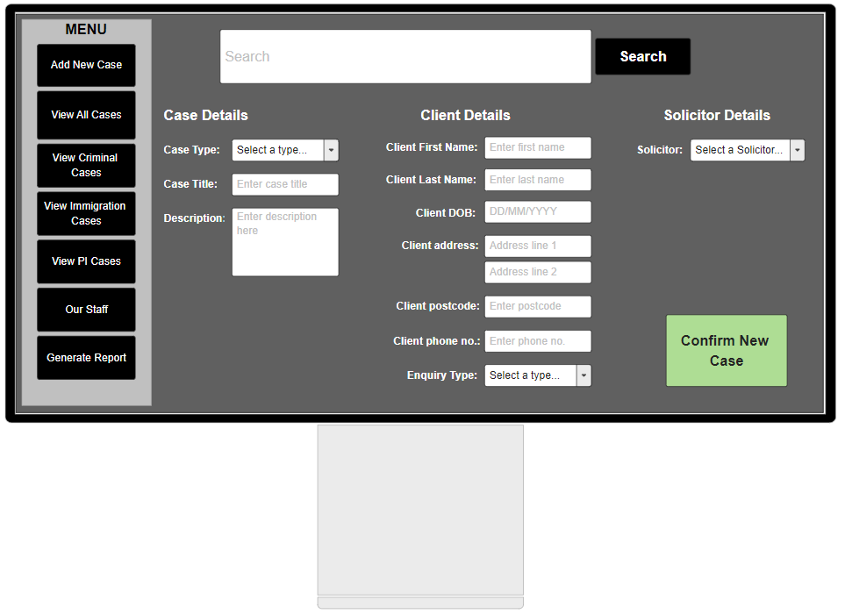

**Solution Planning design**

Figure Solution Planning Add Case design

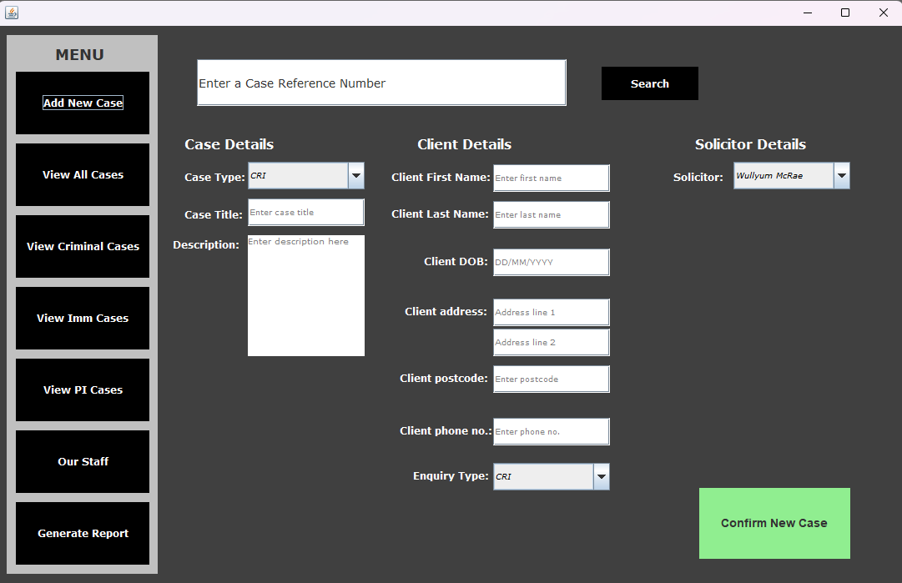

**Actual user interface**

Figure Actual Add Case user interface

#### Searching

**Actual user interface**

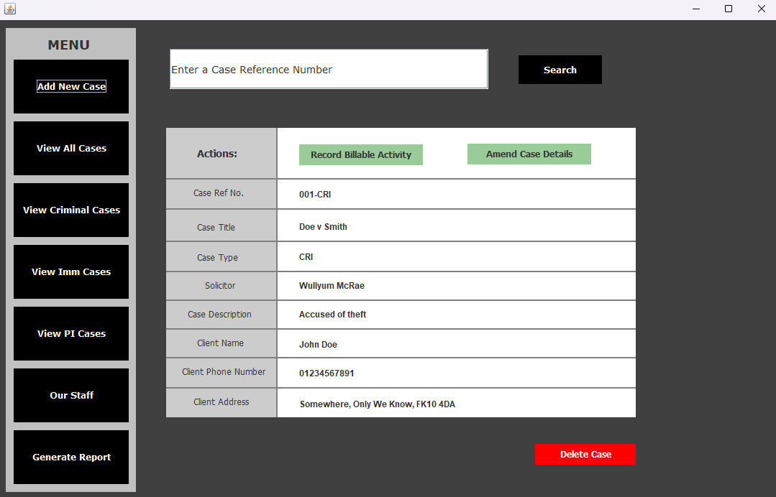

Figure Actual Search Result interface

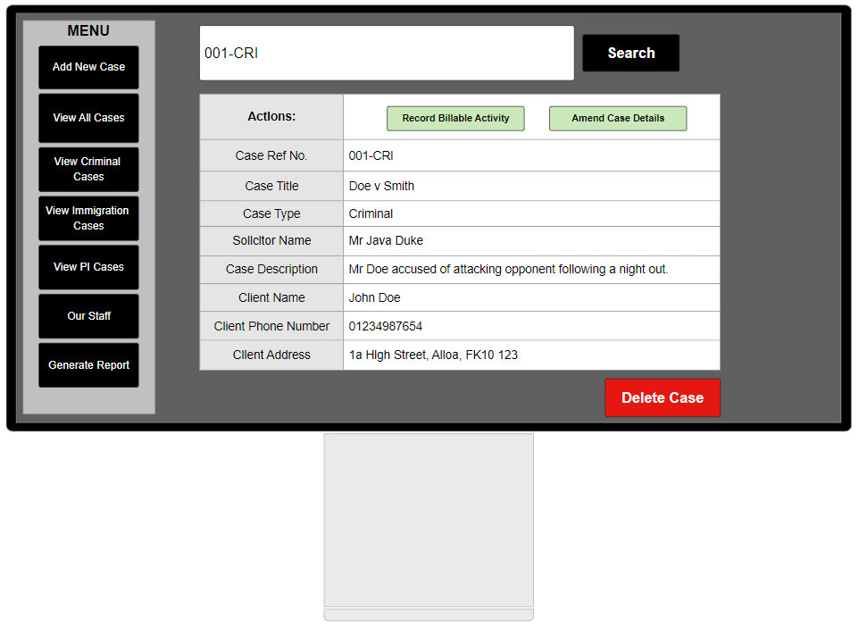

**Solution Planning design**

Figure Solution Planning Search Result design

## Error Handling

### Error Prevention

A number of steps have been taken in this project to implement error handling. The View model, for example, makes use of the enum class CaseType to allow the user to select a Solicitor name from the dropdown list. This prevents any typing errors and forces the user to select a value we already know is valid:

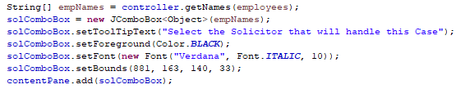

Figure ComboBox to prevent user error

Furthermore, a variety of tooltip texts have been programmed where a lot of data input is required. In AddCaseInterface.java, for example, the tooltip text displayed when the mouse hovers over the postcode text field is set to:

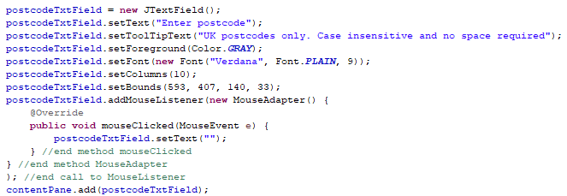

Figure Postcode tooltip text

### Validation Routines

This report has already discussed various regular expressions that have been implemented. It has also showed some initial testing of those validation methods. With these validation methods now integrated into the overall system, the relevant Controller classes are called upon when validation is necessary. For example, after the user enters data and wants to add a new Case, the ActionPerformed method is invoked:

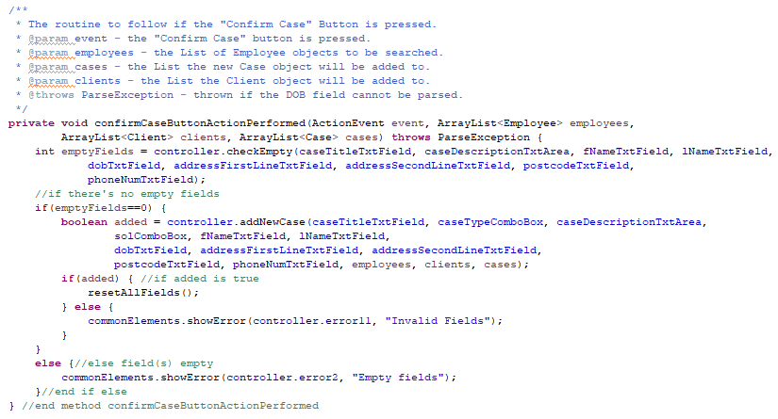

Figure View interacting with Controller for validation routine

To breakdown the above code snippet:

* the user will press “Confirm”, which triggers the method confirmCaseButtonActionPerformed;
* this method sends the data to the Controller to check for empty fields;
* if the Controller says there’s no empty fields:
  + the Controller uses the input to add the new Case to the List:
    - if it successfully adds the Case (if it returns true), added holds a value of true and all the fields are reset to their initial state
    - if it does not successfully add the Case, this means there is invalid data, and the class CommonElements (View) comes into action by showing an error message
* if the Controller says there are empty fields:
  + the class CommonElements (View) comes into action by showing an error message.

When the method addNewCase (found in NewCaseController.java) is called, it calls upon several methods that are written to receive valid data only. To give one example of this, method addNewCase will call the method getValidDob(JTextField dobTxtField) to return a valid date of birth:

Figure Method used in validation routine

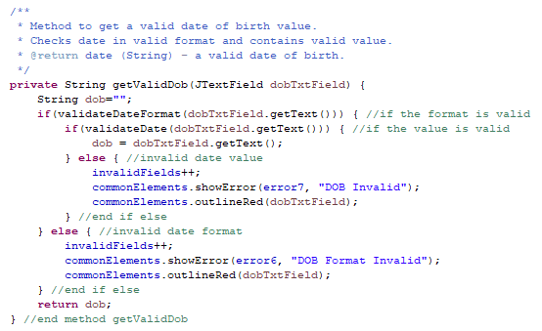

The method above sends the input for dob to the method validateDate, which runs the input through the regular expression to check if the data is acceptable or not. It will also try to parse this value since it will be received as a String, but is stored as type Date:

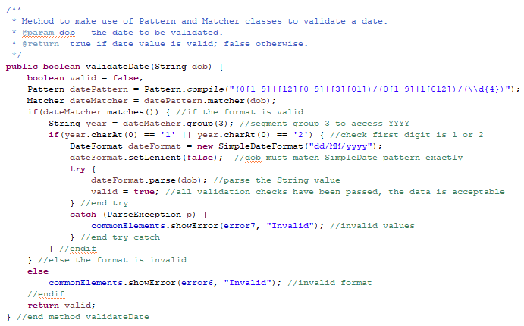

Figure Validation for date of birth

From the above we can see that the validation is performed through the Controller. If errors occur, the View model comes into play. The Person class in the business model includes error handling for the date of birth field too:

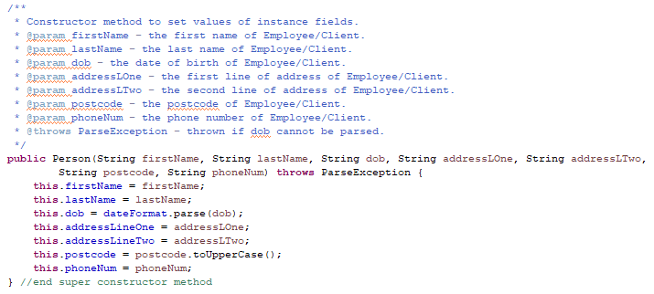

Figure Person constructor throws ParseException

Ultimately, if the system is unable to parse the date of birth in the Business model, the View model is instructed to display the relevant error message.

In addition, the use case “Log In” also contains validation routines. For example, LogInController.java contains a method signIn(JTextField usernameTxtField, JPasswordField pwField) that reads in log in details from a file, and checks the input against this data:

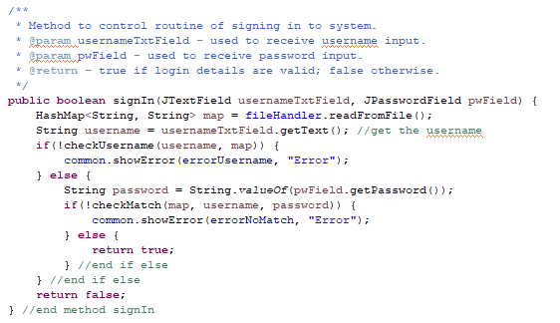

Figure Log In validation routine

The method above checks first if the username input by the user is contained in the Map. If it is not in the Map, the View model displays an error message. Otherwise, it continues to retrieve the password input. It calls on method checkMatch using the Map, the username, and the password, to verify if the password input matches the hash value stored in file. If it doesn’t match, the View model displays an error message. Otherwise, it is a match, the method returns true. When this method invokes the checkMatch method, the abstracted BCrypt code comes into action:

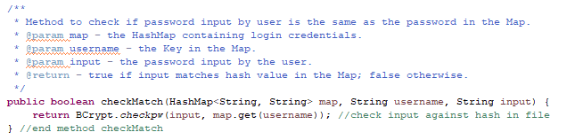

Figure Method contained in LogInController.java

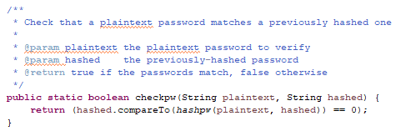

Figure BCrypt method contained in BCrypt.java to compare two String values

Another example of validation routine implementation is found in the resetPassword method, also contained in LogInController.java. This method involves several checks to control the flow of events:

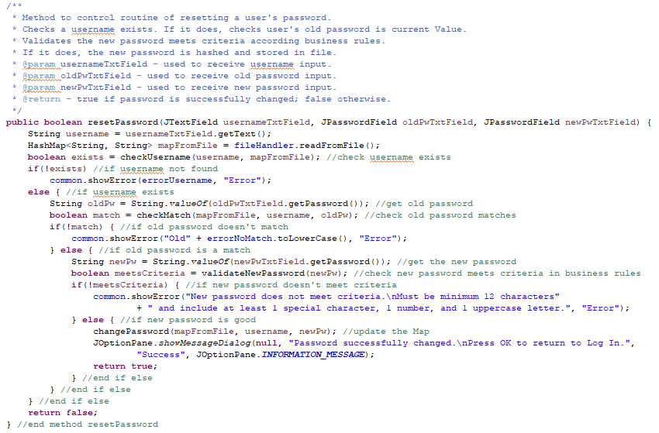

Figure Validation routine for resetting password

The code above shows:

* check that a given username exists in the Map;
  + if it doesn’t, View displays an error message;
  + if it’s found, continue to get the old password value;
    - if the old password input is not matched to the Value in the Map, View displays an error;
    - if old password input is a match, continue to get new password value;
      * if the new password value does not meet the criteria stipulated by business rules, View displays an error;
      * if the new password value is acceptable, update the Map.

There are other examples of validation routines throughout the program, particularly in Controller classes.

### Exception Handling

The program makes use of appropriate exception handling in addition to error prevention and validation routines. This can be seen at Figure 102, Figure 104, and Figure 105, where Figure 105 represents the Person class in the Model section throwing a ParseException if the date of birth cannot be parsed, Figure 102 similarly represents throwing a ParseException if the date of birth cannot be parsed, and Figure 104 represents the try catch statement which instructs the View model what to if this exception is thrown. In addition, when the ActionPerformed method registered to the “Confirm Case” button is invoked, the program is instructed on what to do if a ParseException is caught:

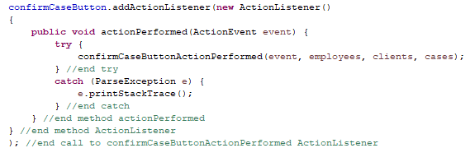

Figure View model try catch statement

Another example of exception handling can be seen in SearchCasesController.java. In the method that outputs Case details to the console, the try catch statements will trigger the View model to come into play if the Case List is empty:

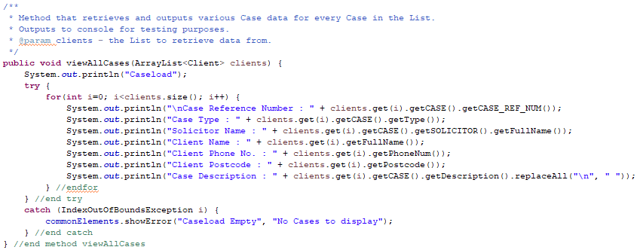

Figure Try catch statement checks for empty List

There’s quite a lot of use of try catch statements contained in FileIO.java too. For example, the method checkFiles uses a try catch statement to catch an IOException:

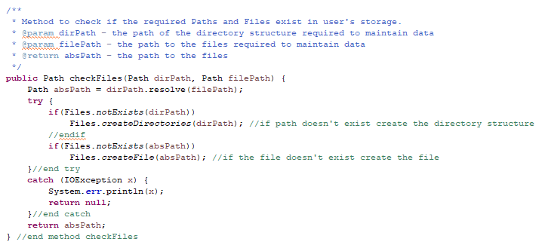

Figure Try catch statement

The purpose of this method is to establish if a given directory and a given file already exists on the user’s device. If they do not exist, this method creates the directory and text file. File handling can often throw an IOException when an input/output operation either fails or is interrupted for whatever reason.

## JavaDocs

To conclude this report, the final element to make reference to is internal documentation. The screenshots contained throughout this report show good evidence of internal documentation. The JavaDocs have been generated and submitted in a folder named “JavaDocs”. The screenshot below shows the hierarchy of the classes contained in each package:

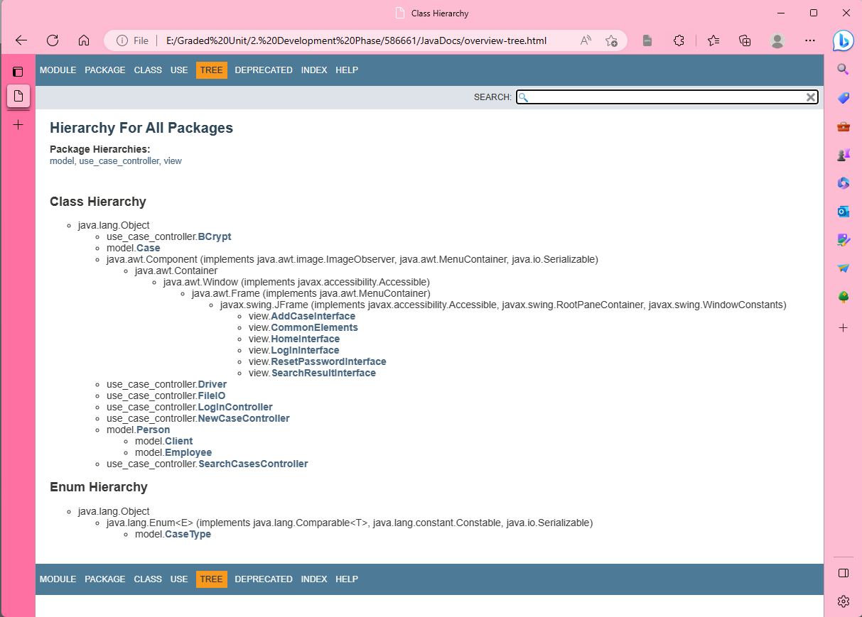

Figure JavaDoc generation - class hierarchy

# Updated Class Diagram

At this point, with JavaDocs now generated and testing having taken place, it would be interesting to be able to compare an updated class diagram with the class diagram provided in Solution Planning (which can be found under Appendix 1). The updated class diagram is quite large, so it has been submitted separately as a png file (“ClassDiagram14May.umlcd”) for readability as it is far easier to zoom in this way.

Comparing the two class diagrams side by side shows quite a lot of differences. It seems this is largely owing to the use of the MVC organisation technique. A lot of the foundations are still there – for example, including an abstract class Person which both Client and Employee extend. It also shows a better use of abstraction, particularly in the use of BCrypt.java to store hashed password values. The updated class diagram also shows implementation of encapsulation, where fields are marked private or protected wherever possible and only appropriate accessor and mutator methods are included. Furthermore, there’s also evidence of polymorphism shown in the class diagram, for example in the class SearchResultInterface where there are two constructor methods – one that displays a single Case object using a Case reference number along with the Employees, Clients, and Cases Lists; and one that takes in the three Lists only to display all details of all Cases.

Overall, after reflecting on the updated class diagram, I think the MVC organisation complements an object‑oriented program really well. It separates the validation methods nicely, and it prevents any one class from bearing too much responsibility.

# Appendix

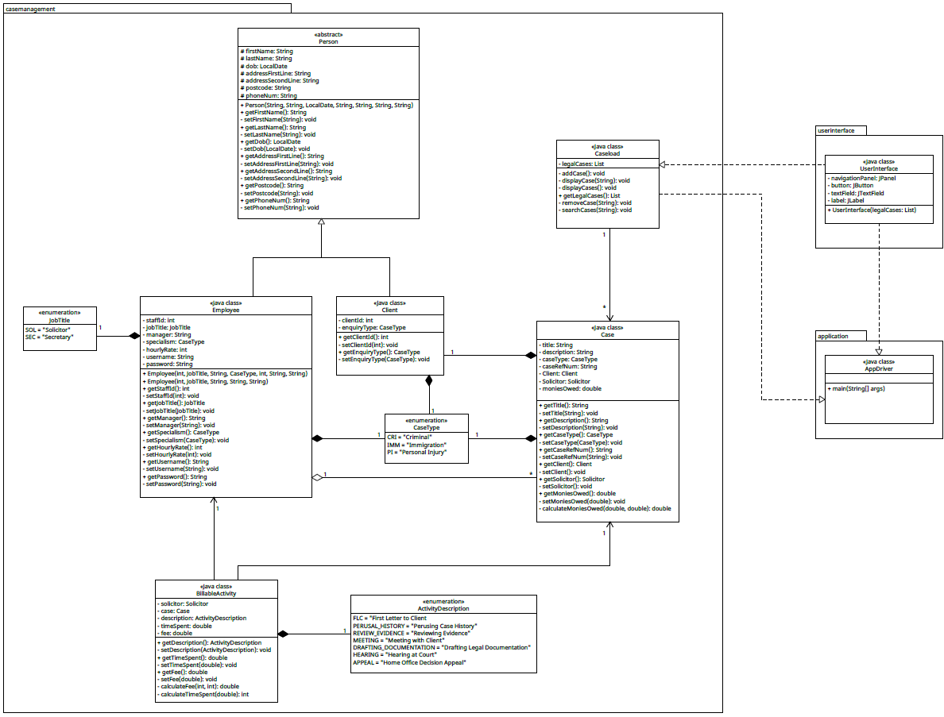

Figure Refined Class Diagram

## Appendix 1

## Appendix 2

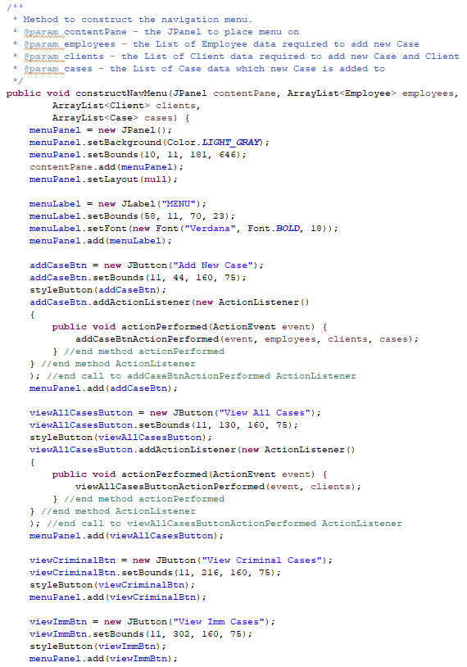

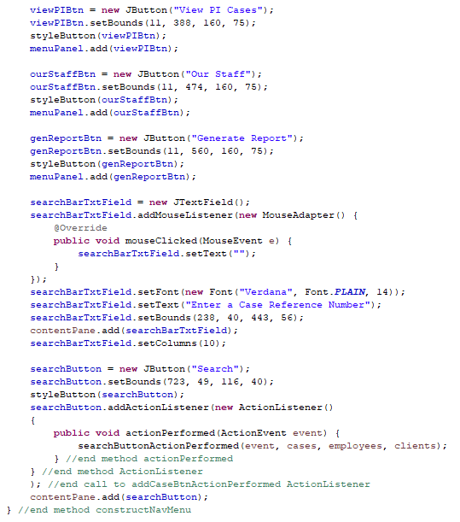

# Bibliography

asecuritysite.com. (n.d.). *Hash Speed Test*. [online] Available at: https://asecuritysite.com/encryption/htest.

BULK DATA TRANSFER: ADDITIONAL VALIDATION FOR CAS UPLOAD. (n.d.). Available at: https://assets.publishing.service.gov.uk/government/uploads/system/uploads/attachment_data/file/488478/Bulk_Data_Transfer_-_additional_validation_valid_from_12_November_2015.pdf [Accessed 4 Apr. 2023].

Codecademy. (n.d.). *MVC: Model, View, Controller*. [online] Available at: https://www.codecademy.com/article/mvc.

Cryptoguiding. (2023). *How many salt rounds BCrypt?* (2023). [online] Available at: https://cryptoguiding-com.ngontinh24.com/articles/how-many-salt-rounds-bcrypt#toc-7 [Accessed 13 May 2023].

developer.mozilla.org. (n.d.). *MVC - MDN Web Docs Glossary: Definitions of Web-related terms | MDN*. [online] Available at: https://developer.mozilla.org/en-US/docs/Glossary/MVC#mvc_on_the_web.

docs.oracle.com. (n.d.). *Java Development Kit Version 17 API Specification*. [online] Available at: https://docs.oracle.com/en/java/javase/17/docs/api/java.base/java/security/SecureRandom.html [Accessed 12 May 2023].

docs.oracle.com. (n.d.). *Java Development Kit Version 17 API Specification*. [online] Available at: https://docs.oracle.com/en/java/javase/17/docs/specs/security/standard-names.html#messagedigest-algorithms [Accessed 12 May 2023].

docs.oracle.com. (n.d.). *JPasswordField (Java Platform SE 7 )*. [online] Available at: https://docs.oracle.com/javase/7/docs/api/javax/swing/JPasswordField.html.

docs.oracle.com. (n.d.). *SimpleDateFormat (Java Platform SE 7 )*. [online] Available at: https://docs.oracle.com/javase/7/docs/api/java/text/SimpleDateFormat.html.

faq.whatsapp.com. (n.d.). *About end-to-end encryption | WhatsApp Help Center*. [online] Available at: https://faq.whatsapp.com/820124435853543.

fireup.pro. (n.d.). *Advantages of Using MVC in Application Development - fireup.pro*. [online] Available at: https://fireup.pro/blog/advantages-of-using-mvc-in-application-development.

Gamma, E., Helm, R., Johnson, R. and Vlissides, J. (1994). *Design patterns : elements of reusable object-oriented software*. Boston: Addison-Wesley.

help.eclipse.org. (n.d.). *Help - Eclipse Platform*. [online] Available at: https://help.eclipse.org/latest/index.jsp?topic=%2Forg.eclipse.wb.doc.user%2Fhtml%2Findex.html [Accessed 13 May 2023].

Java Code Examples. (2021). *Java RegEx - Validate dd/mm/yyyy & mm/dd/yyyy Date Format*. [online] Available at: https://www.javacodeexamples.com/java-regex-validate-dd-mm-yyyy-mm-dd-yyyy-date-format/3457.

Larman, C. (2005). *Applying UML and patterns : an introduction to object-oriented analysis and design and iterative development*. Upper Saddle River, N.J.: Prentice Hall Ptr.

Martin Paul Eve (2016). *Password*. New York: Bloomsbury, Bloomsbury Academic, An Imprint Of Bloomsbury Publishing Inc.

Millington, S. (2018). *Hashing a Password in Java | Baeldung*. [online] Baeldung. Available at: https://www.baeldung.com/java-password-hashing.

Regular Expressions Cookbook, 2nd edition, Jan Goyvaerts and Steven Levithan.

Schlin, B. (2018). *What the f**k is MVC? Explained with easy analogy*. [online] Medium. Available at: https://medium.com/@blakeschlin/what-the-f-k-is-mvc-explained-with-real-world-analogy-e088a9a8b787 [Accessed 29 March. 2023].

Security. (n.d.). *What does password salting do to protect against bad actors?* [online] Available at: https://www.techtarget.com/searchsecurity/definition/salt#:~:text=What%20is%20password%20salting%3F.

tutorialspoint (2019). *MVC Framework - Introduction - Tutorialspoint*. [online] Tutorialspoint.com. Available at: https://www.tutorialspoint.com/mvc_framework/mvc_framework_introduction.htm.

Wikipedia Contributors (2019). *SHA-2*. [online] Wikipedia. Available at: https://en.wikipedia.org/wiki/SHA-2.

www.tutorialspoint.com. (n.d.). *Java.lang.System.nanoTime() Method - Tutorialspoint*. [online] Available at: https://www.tutorialspoint.com/java/lang/system_nanotime.htm.

www.w3schools.in. (n.d.). *What is MVC Architecture?* [online] Available at: https://www.w3schools.in/mvc-architecture?utm_content=cmp-true [Accessed 10 Apr. 2023].

1. Found at https://medium.com/@blakeschlin/what-the-f-k-is-mvc-explained-with-real-world-analogy-e088a9a8b787
2. Found at https://developer.mozilla.org/en-US/docs/Glossary/MVC#mvc_on_the_web
3. Found at https://www.w3schools.in/mvc-architecture?utm_content=cmp-true
4. Found at https://www.tutorialspoint.com/mvc_framework/mvc_framework_introduction.htm
5. As I’m simply trying to establish how different these two algorithms are in terms of speed, I am not going to worry too much about how accurate a duration using this will result in; the aim here is to get a rough idea of the difference in duration of each process.